Practical 1
Aim: Demonstrate a simple "hello world " message
Xmlfile
<?xml version="1.0" encoding="utf-8"?>
<android.support.constraint.ConstraintLayoutxmlns:android="http://schemas.android.com/apk/res/android"
xmlns:app="http://schemas.android.com/apk/res-auto"
xmlns:tools="http://schemas.android.com/tools"
android:layout_width="match_parent"
android:layout_height="match_parent"
tools:context="com.example.ashok.hello.MainActivity">
</android.support.constraint.ConstraintLayout>

Javafile
TextView d=(TextView)findViewById(R.id.textView);
d.setText("Hello World");

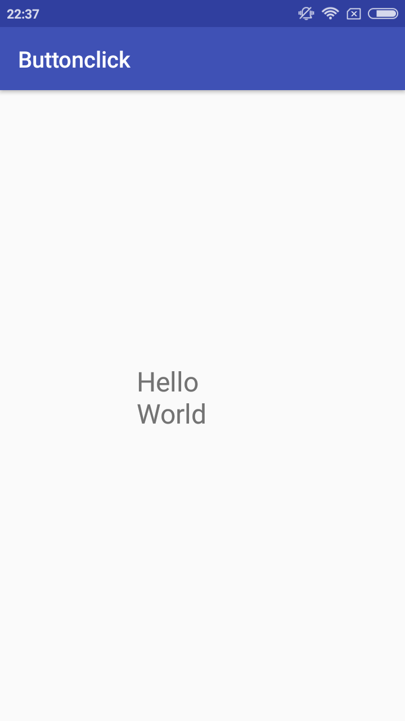

PRACTICAL 2
Aim: Demonstrate the use of Layout
simple calculator
Xmlfile
<?xml version="1.0" encoding="utf-8"?>
<RelativeLayoutxmlns:android="http://schemas.android.com/apk/res/android"
xmlns:app="http://schemas.android.com/apk/res-auto"
xmlns:tools="http://schemas.android.com/tools"
android:layout_width="match_parent"
android:layout_height="match_parent"
tools:context="com.example.ashok.calculator.MainActivity">
<TextView
android:id="@+id/textView"
android:layout_width="159dp"
android:layout_height="57dp"
android:text="enter a no"
android:textSize="24sp"
app:layout_constraintBottom_toBottomOf="parent"
app:layout_constraintHorizontal_bias="0.129"
app:layout_constraintLeft_toLeftOf="parent"
app:layout_constraintRight_toRightOf="parent"
app:layout_constraintTop_toTopOf="parent"
app:layout_constraintVertical_bias="0.068" />
<EditText
android:id="@+id/e1"
android:layout_width="140dp"
android:layout_height="52dp"
android:ems="10"
android:inputType="textPersonName"
app:layout_constraintBottom_toBottomOf="parent"
app:layout_constraintHorizontal_bias="0.878"
app:layout_constraintLeft_toLeftOf="parent"
app:layout_constraintRight_toRightOf="parent"
app:layout_constraintTop_toTopOf="parent"
app:layout_constraintVertical_bias="0.067" />
<TextView
android:id="@+id/textView2"
android:layout_width="158dp"
android:layout_height="52dp"
android:text="enter a no"
android:textSize="24sp"
app:layout_constraintBottom_toBottomOf="parent"
app:layout_constraintHorizontal_bias="0.129"
app:layout_constraintLeft_toLeftOf="parent"
app:layout_constraintRight_toRightOf="parent"
app:layout_constraintTop_toTopOf="parent"
app:layout_constraintVertical_bias="0.235" />
<EditText
android:id="@+id/e2"
android:layout_width="140dp"
android:layout_height="52dp"
android:ems="10"
android:inputType="textPersonName"
app:layout_constraintBottom_toBottomOf="parent"
app:layout_constraintHorizontal_bias="0.877"
app:layout_constraintLeft_toLeftOf="parent"
app:layout_constraintRight_toRightOf="parent"
app:layout_constraintTop_toTopOf="parent"
app:layout_constraintVertical_bias="0.233" />
<TextView
android:id="@+id/tv"
android:layout_width="191dp"
android:layout_height="70dp"
android:text="Result"
android:textSize="24sp"
app:layout_constraintBottom_toBottomOf="parent"
app:layout_constraintLeft_toLeftOf="parent"
app:layout_constraintRight_toRightOf="parent"
app:layout_constraintTop_toTopOf="parent"
app:layout_constraintVertical_bias="0.818" />
<Button
android:id="@+id/b1"
android:layout_width="103dp"
android:layout_height="66dp"
android:text="+"
android:textSize="30sp"
app:layout_constraintBottom_toBottomOf="parent"
app:layout_constraintHorizontal_bias="0.202"
app:layout_constraintLeft_toLeftOf="parent"
app:layout_constraintRight_toRightOf="parent"
app:layout_constraintTop_toTopOf="parent"
app:layout_constraintVertical_bias="0.421" />
<Button
android:id="@+id/b2"
android:layout_width="103dp"
android:layout_height="66dp"
android:text="-"
android:textSize="30sp"
app:layout_constraintBottom_toBottomOf="parent"
app:layout_constraintHorizontal_bias="0.75"
app:layout_constraintLeft_toLeftOf="parent"
app:layout_constraintRight_toRightOf="parent"
app:layout_constraintTop_toTopOf="parent"
app:layout_constraintVertical_bias="0.42" />
<Button
android:id="@+id/b3"
android:layout_width="106dp"
android:layout_height="66dp"
android:text="*"
android:textSize="30sp"
app:layout_constraintBottom_toBottomOf="parent"
app:layout_constraintHorizontal_bias="0.205"
app:layout_constraintLeft_toLeftOf="parent"
app:layout_constraintRight_toRightOf="parent"
app:layout_constraintTop_toTopOf="parent"
app:layout_constraintVertical_bias="0.595" />
<Button
android:id="@+id/b4"
android:layout_width="105dp"
android:layout_height="70dp"
android:text="/"
android:textSize="30sp"
app:layout_constraintBottom_toBottomOf="parent"
app:layout_constraintHorizontal_bias="0.761"
app:layout_constraintLeft_toLeftOf="parent"
app:layout_constraintRight_toRightOf="parent"
app:layout_constraintTop_toTopOf="parent"
app:layout_constraintVertical_bias="0.6" />
</RelativeLayout>
Javafile
final Button b1, b2, b3, b4;
final EditText e1, e2;
final TextView tv;
e1=(EditText)findViewById(R.id.e1);
e2=(EditText)findViewById(R.id.e2);
tv=(TextView)findViewById(R.id.tv);
b1 =(Button) findViewById(R.id.b1);
b2 =(Button) findViewById(R.id.b2);
b3 =(Button)findViewById(R.id.b3);
b4=(Button)findViewById(R.id.b4);
b1.setOnClickListener(new View.OnClickListener() {
@Override
public void onClick(View v) {
String n1,n2;
n1=e1.getText().toString();
n2=e1.getText().toString();
int op=Integer.parseInt(n1)+Integer.parseInt(n2);
tv.setText(op);
}
});
b2.setOnClickListener(new View.OnClickListener() {
@Override
public void onClick(View v) {
String n1,n2;
n1=e1.getText().toString();
n2=e1.getText().toString();
int op=Integer.parseInt(n1)-Integer.parseInt(n2);
tv.setText(op);
}
});
b3.setOnClickListener(new View.OnClickListener() {
@Override
public void onClick(View v) {
String n1,n2;
n1=e1.getText().toString();
n2=e1.getText().toString();
int op=Integer.parseInt(n1)*Integer.parseInt(n2);
tv.setText(op);
}
});
b4.setOnClickListener(new View.OnClickListener() {
@Override
public void onClick(View v) {
String n1,n2;
n1=e1.getText().toString();
n2=e1.getText().toString();
int op=Integer.parseInt(n1)/Integer.parseInt(n2);
tv.setText(op);
}
});

addition operation
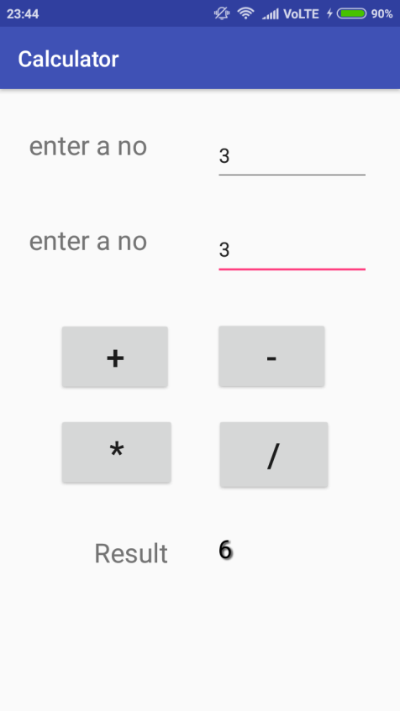
division operation

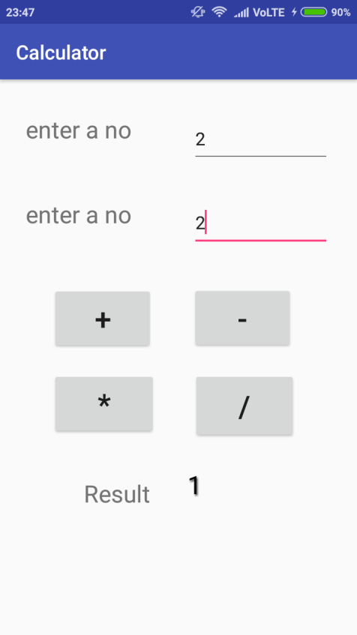

PRACTICAL 3

Aim: Programs on Dialogs ,Menus
dialogs
a]TIMEPICKER VIEW
Xml File
<?xml version="1.0" encoding="utf-8"?>
<android.support.constraint.ConstraintLayoutxmlns:android="http://schemas.android.com/apk/res/android"
xmlns:app="http://schemas.android.com/apk/res-auto"
xmlns:tools="http://schemas.android.com/tools"
android:layout_width="match_parent"
android:layout_height="match_parent"
tools:context="com.example.ashok.timepicker.MainActivity">
<TextView
android:id="@+id/tv"
android:layout_width="157dp"
android:layout_height="118dp"
android:textSize="24sp"
app:layout_constraintBottom_toBottomOf="parent"
app:layout_constraintLeft_toLeftOf="parent"
app:layout_constraintRight_toRightOf="parent"
app:layout_constraintTop_toTopOf="parent"
app:layout_constraintVertical_bias="0.721" />
<Button
android:id="@+id/button"
android:layout_width="174dp"
android:layout_height="128dp"
android:text="Show Timepicker"
app:layout_constraintBottom_toBottomOf="parent"
app:layout_constraintHorizontal_bias="0.522"
app:layout_constraintLeft_toRightOf="parent"
app:layout_constraintRight_toRightOf="parent"
app:layout_constraintTop_toTopOf="parent"
app:layout_constraintVertical_bias="0.282" />
</android.support.constraint.ConstraintLayout>
Java File
final Button btn=(Button)findViewById(R.id.button);
final TextView tv=(TextView)findViewById(R.id.tv);
btn.setOnClickListener(new View.OnClickListener() {
@Override
public void onClick(View view) {
Calendar cal=Calendar.getInstance();
int our_hours=cal.get(Calendar.HOUR_OF_DAY);
int our_min=cal.get(Calendar.MINUTE);
TimePickerDialogtpd=new TimePickerDialog(MainActivity.this, new TimePickerDialog.OnTimeSetListener() {
@Override
public void onTimeSet(TimePicker view, int hourofday, int minute) {
tv.setText("Time is"+hourofday+":"+minute);
}
},our_hours,our_min,true);
tpd.show();
}
});
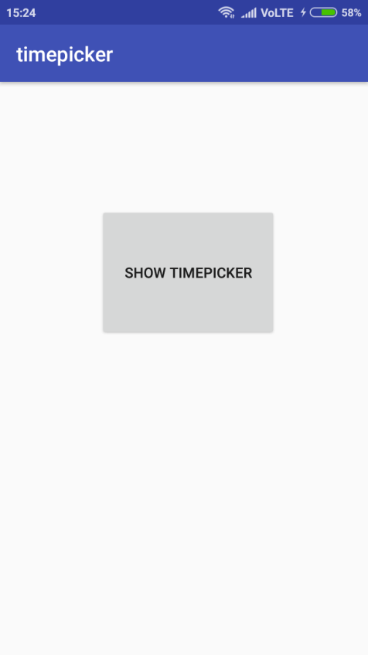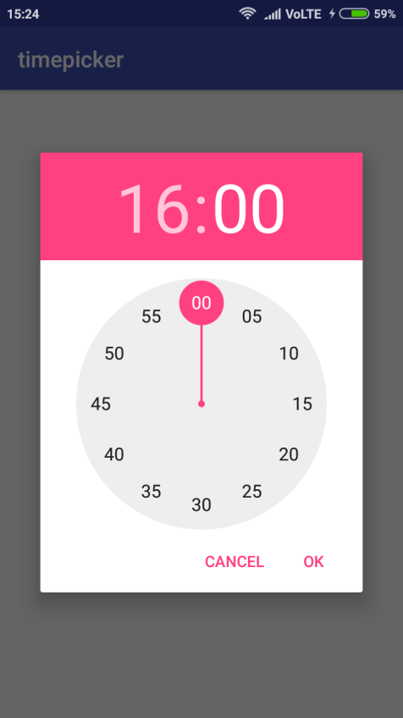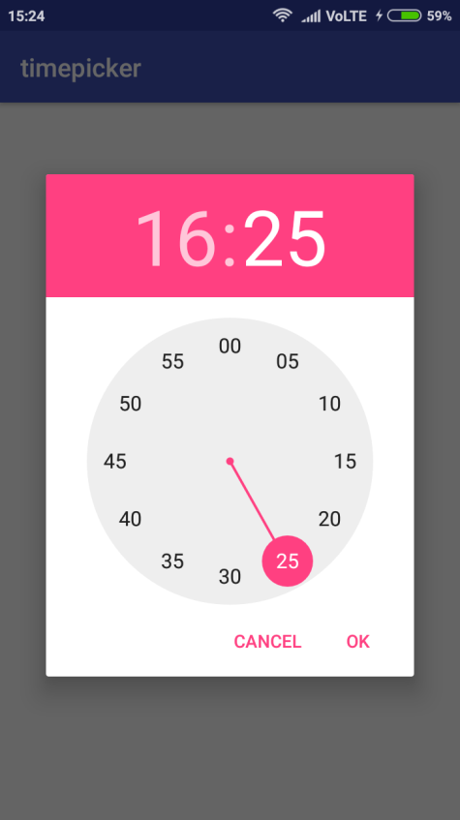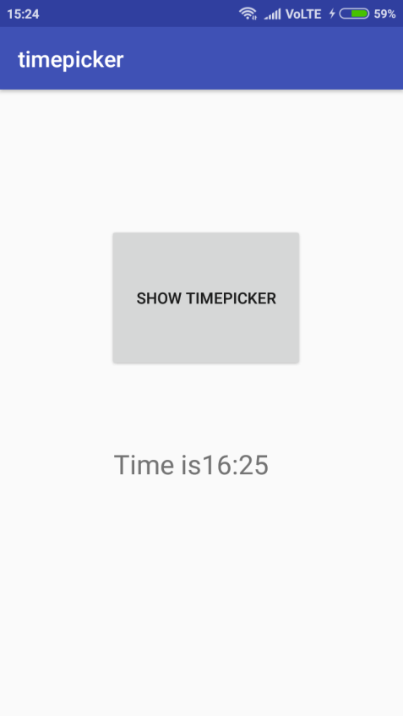

b)datepicker view
Xml File
<?xml version="1.0" encoding="utf-8"?>
<android.support.constraint.ConstraintLayoutxmlns:android="http://schemas.android.com/apk/res/android"
xmlns:app="http://schemas.android.com/apk/res-auto"
xmlns:tools="http://schemas.android.com/tools"
android:layout_width="match_parent"
android:layout_height="match_parent"
tools:context="com.example.ashok.datepicker.MainActivity">
<Button
android:id="@+id/button"
android:layout_width="wrap_content"
android:layout_height="wrap_content"
android:padding="@android:dimen/app_icon_size"
android:text="@string/show_datepicker"
app:layout_constraintBottom_toBottomOf="parent"
app:layout_constraintHorizontal_bias="0.416"
app:layout_constraintLeft_toLeftOf="parent"
app:layout_constraintRight_toRightOf="parent"
app:layout_constraintTop_toTopOf="parent"
app:layout_constraintVertical_bias="0.181"
app:layout_editor_absoluteX="@android:dimen/app_icon_size"
app:layout_editor_absoluteY="@android:dimen/app_icon_size" />
<TextView
android:id="@+id/textView"
android:layout_width="245dp"
android:layout_height="91dp"
android:hint="@string/date"
android:paddingEnd="@android:dimen/notification_large_icon_height"
android:paddingLeft="@android:dimen/app_icon_size"
android:paddingRight="@android:dimen/notification_large_icon_height"
android:paddingStart="@android:dimen/app_icon_size"
app:layout_constraintBottom_toBottomOf="parent"
app:layout_constraintHorizontal_bias="0.417"
app:layout_constraintLeft_toLeftOf="parent"
app:layout_constraintRight_toRightOf="parent"
app:layout_constraintTop_toTopOf="parent"
app:layout_constraintVertical_bias="0.583" />
</android.support.constraint.ConstraintLayout>
Javafile
final Button btn=(Button)findViewById(R.id.button);
final TextView tv=(TextView)findViewById(R.id.textView);
btn.setOnClickListener(new View.OnClickListener() {
@Override
public void onClick(View view) {
Calendar cal=Calendar.getInstance();
int our_day=cal.get(Calendar.DAY_OF_MONTH);
int our_month=cal.get(Calendar.MONTH);
int our_year=cal.get(Calendar.YEAR);
DatePickerDialogdpd=new DatePickerDialog(MainActivity.this, new DatePickerDialog.OnDateSetListener() {
@Override
public void onDateSet(DatePicker view, int year, int monthofyear, int dayofmonth) {
tv.setText("Date is"+dayofmonth+"/"+monthofyear+"/"+year);
}
},our_year,our_month,our_day);
dpd.show();
}
});
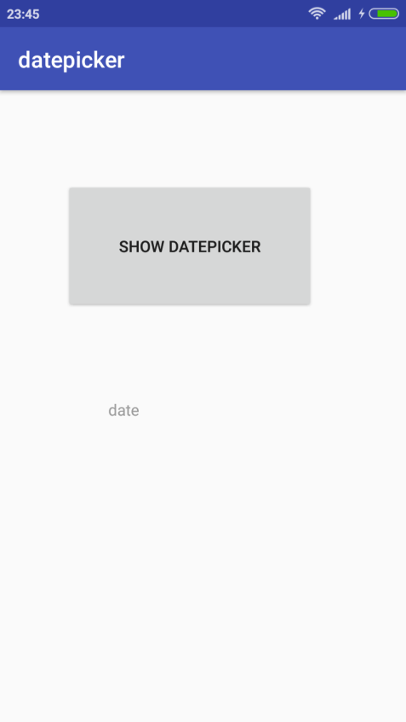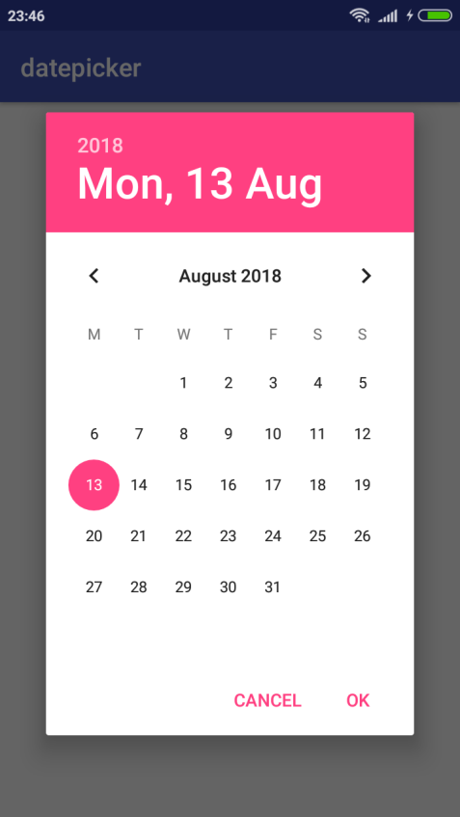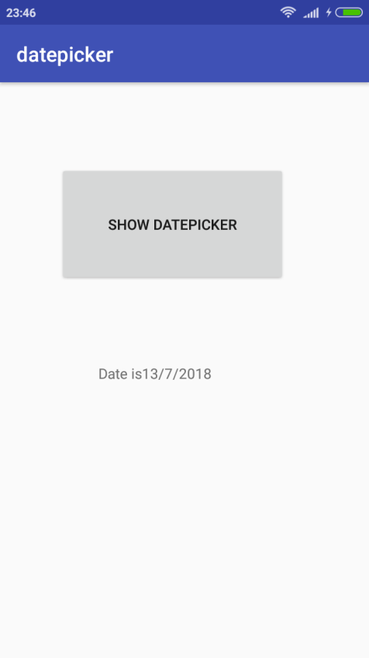

c)Alert
Xmlfile
<?xml version="1.0" encoding="utf-8"?>
<android.support.constraint.ConstraintLayoutxmlns:android="http://schemas.android.com/apk/res/android"
xmlns:app="http://schemas.android.com/apk/res-auto"
xmlns:tools="http://schemas.android.com/tools"
android:layout_width="match_parent"
android:layout_height="match_parent"
tools:context="com.example.ashok.alert.MainActivity">
<Button
android:id="@+id/button"
android:layout_width="226dp"
android:layout_height="150dp"
android:text="@string/alert_show"
app:layout_constraintBottom_toTopOf="parent"
app:layout_constraintLeft_toRightOf="parent"
app:layout_constraintRight_toLeftOf="parent"
app:layout_constraintTop_toBottomOf="parent" />
</android.support.constraint.ConstraintLayout>
Javafile
final Button b=(Button)findViewById(R.id.button);
b.setOnClickListener(new View.OnClickListener() {
@Override
public void onClick(View view) {
AlertDialog.Builder alert=new AlertDialog.Builder(MainActivity.this);
alert.setTitle("My alert box");
alert.setMessage("Do you want to continue");
alert.setPositiveButton("ok", new DialogInterface.OnClickListener() {
@Override
public void onClick(DialogInterfacedialogInterface, int i) {
Toast.makeText(MainActivity.this, "ok choosed", Toast.LENGTH_SHORT).show();
}
});
alert.setNegativeButton("cancel", new DialogInterface.OnClickListener() {
@Override
public void onClick(DialogInterfacedialogInterface, int i) {
Toast.makeText(MainActivity.this, "cancel choosed", Toast.LENGTH_SHORT).show();
}
});
alert.show();
}
});
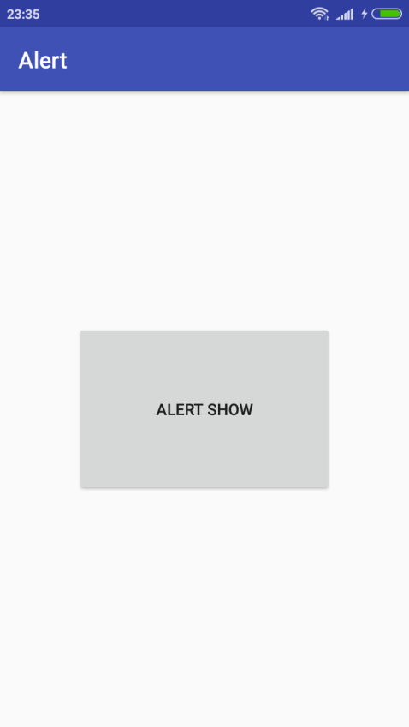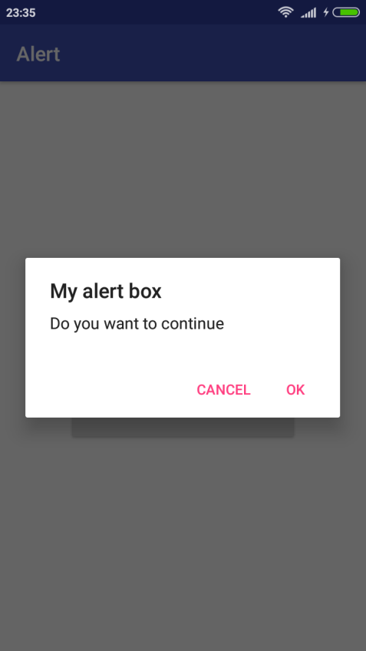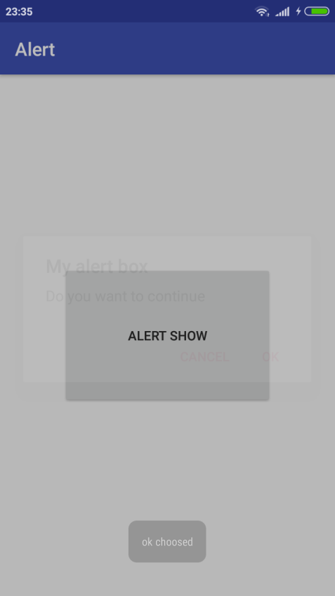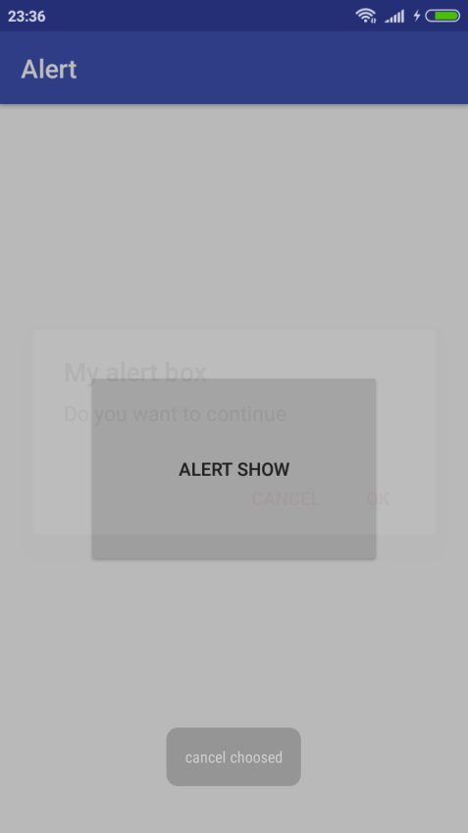

MENUS
a)option menu
Xmlfile
activity_main.xml
<?xml version="1.0" encoding="utf-8"?>
<android.support.constraint.ConstraintLayoutxmlns:android="http://schemas.android.com/apk/res/android"
xmlns:app="http://schemas.android.com/apk/res-auto"
xmlns:tools="http://schemas.android.com/tools"
android:layout_width="match_parent"
android:layout_height="match_parent"
tools:context="com.example.ashok.optionmenu.MainActivity">
</android.support.constraint.ConstraintLayout>
menu.xml
<?xml version="1.0" encoding="utf-8"?>
<menu xmlns:android="http://schemas.android.com/apk/res/android">
<item
android:id="@+id/a1"
android:title="Add"/>
<item
android:id="@+id/a2"
android:title="Edit"/>
<item
android:id="@+id/a3"
android:title="Delete"/>
<item
android:id="@+id/a4"
android:title="Save"/>
</menu>
Javafile
package com.example.ashok.optionmenu;
import android.support.v7.app.AppCompatActivity;
import android.os.Bundle;
import android.view.Menu;
import android.view.MenuInflater;
import android.view.MenuItem;
import android.widget.Toast;
public class MainActivityextends AppCompatActivity {
@Override
protected void onCreate(Bundle savedInstanceState) {
super.onCreate(savedInstanceState);
setContentView(R.layout.activity_main);
}
@Override
public booleanonCreateOptionsMenu(Menu menu) {
MenuInflater mi=getMenuInflater();
mi.inflate(R.menu.menu,menu);
return super.onCreateOptionsMenu(menu);
}
@Override
public booleanonOptionsItemSelected(MenuItem item) {
switch(item.getItemId())
{
case R.id.a1:
Toast.makeText(MainActivity.this,"add is selected",Toast.LENGTH_SHORT).show();
break;
case R.id.a2:
Toast.makeText(MainActivity.this,"edit is selected",Toast.LENGTH_SHORT).show();
break;
case R.id.a3:
Toast.makeText(MainActivity.this,"delete is selected",Toast.LENGTH_SHORT).show();
break;
case R.id.a4:
Toast.makeText(MainActivity.this,"save is selected",Toast.LENGTH_SHORT).show();
break;
default:
Toast.makeText(MainActivity.this,"please select options",Toast.LENGTH_SHORT).show();
}
return super.onOptionsItemSelected(item);
}
}
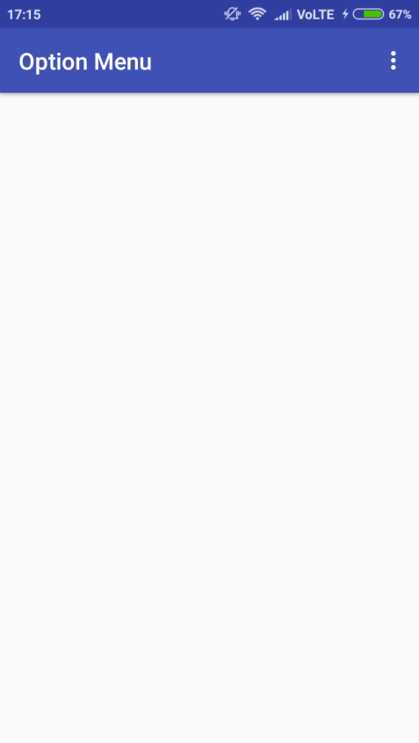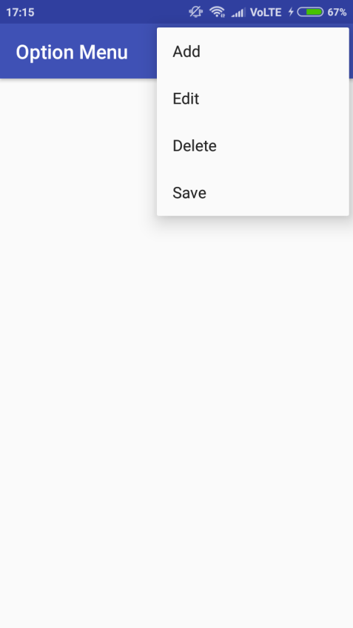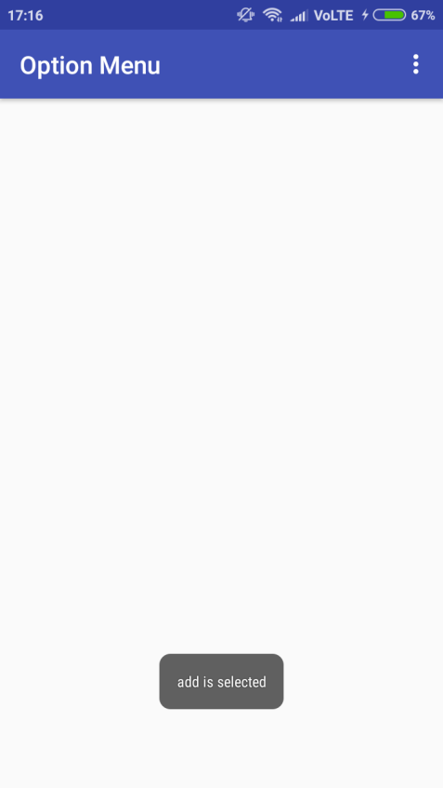

b)context menu
Xmlfile
activitymain.xml
<?xml version="1.0" encoding="utf-8"?>
<android.support.constraint.ConstraintLayoutxmlns:android="http://schemas.android.com/apk/res/android"
xmlns:app="http://schemas.android.com/apk/res-auto"
xmlns:tools="http://schemas.android.com/tools"
android:layout_width="match_parent"
android:layout_height="match_parent"
tools:context="com.example.ashok.contextmenu.MainActivity">
<Button
android:id="@+id/button"
android:layout_width="219dp"
android:layout_height="108dp"
android:text="Click"
app:layout_constraintBottom_toBottomOf="parent"
app:layout_constraintBottom_toTopOf="parent"
app:layout_constraintLeft_toLeftOf="parent"
app:layout_constraintRight_toRightOf="parent"
app:layout_constraintTop_toTopOf="parent"
app:layout_constraintVertical_bias="0.31" />
</android.support.constraint.ConstraintLayout>

menu.xml
<?xml version="1.0" encoding="utf-8"?>
<menu xmlns:android="http://schemas.android.com/apk/res/android">
<item
android:id="@+id/a1"
android:title="Add"/>
<item
android:id="@+id/a2"
android:title="Edit"/>
<item
android:id="@+id/a3"
android:title="Delete"/>
<item
android:id="@+id/a4"
android:title="Save"/>
</menu>
Javafile
package com.example.ashok.contextmenu;
import android.support.v7.app.AppCompatActivity;
import android.os.Bundle;
import android.view.ContextMenu;
import android.view.MenuInflater;
import android.view.MenuItem;
import android.view.View;
import android.widget.Button;
import android.widget.Toast;
public class MainActivityextends AppCompatActivity {
@Override
protected void onCreate(Bundle savedInstanceState) {
super.onCreate(savedInstanceState);
setContentView(R.layout.activity_main);
Button btn=(Button)findViewById(R.id.button);
registerForContextMenu(btn);}
@Override
public void onCreateContextMenu(ContextMenu menu, View v, ContextMenu.ContextMenuInfomenuInfo) {
MenuInflater m=getMenuInflater();
m.inflate(R.menu.menu,menu);
super.onCreateContextMenu(menu, v, menuInfo);
}
@Override
public booleanonContextItemSelected(MenuItem item) {
switch(item.getItemId())
{
case R.id.a1:
Toast.makeText(MainActivity.this,"add is selected",Toast.LENGTH_SHORT).show();
break;
case R.id.a2:
Toast.makeText(MainActivity.this,"edit is selected",Toast.LENGTH_SHORT).show();
break;
case R.id.a3:
Toast.makeText(MainActivity.this,"delete is selected",Toast.LENGTH_SHORT).show();
break;
case R.id.a4:
Toast.makeText(MainActivity.this,"save is selected",Toast.LENGTH_SHORT).show();
break;
default:
Toast.makeText(MainActivity.this,"please select options",Toast.LENGTH_SHORT).show();
}
return super.onOptionsItemSelected(item);
}
}
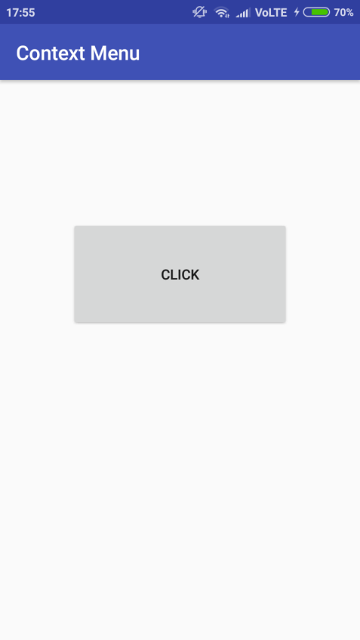
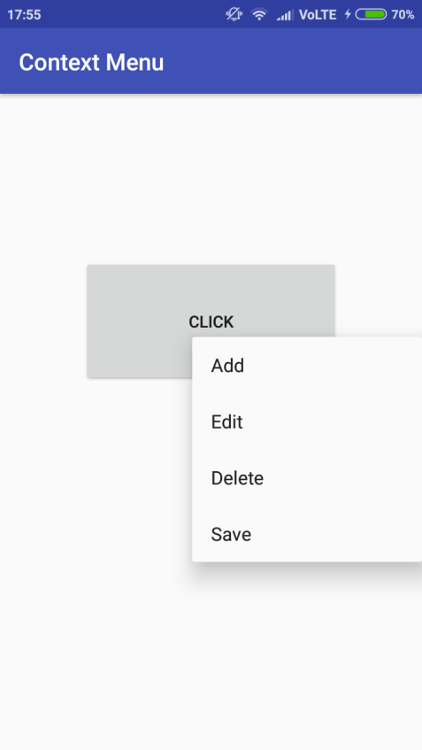
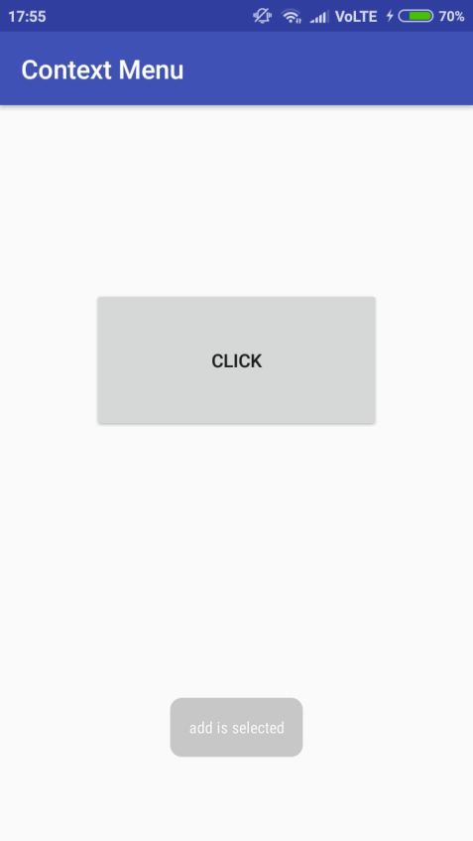

c)popup menu
Xmlfile
activity_main.xml
<?xml version="1.0" encoding="utf-8"?>
<android.support.constraint.ConstraintLayoutxmlns:android="http://schemas.android.com/apk/res/android"
xmlns:app="http://schemas.android.com/apk/res-auto"
xmlns:tools="http://schemas.android.com/tools"
android:layout_width="match_parent"
android:layout_height="match_parent"
tools:context="com.example.ashok.contextmenu.MainActivity">
<Button
android:id="@+id/button"
android:layout_width="219dp"
android:layout_height="108dp"
android:text="Click"
app:layout_constraintBottom_toBottomOf="parent"
app:layout_constraintBottom_toTopOf="parent"
app:layout_constraintLeft_toLeftOf="parent"
app:layout_constraintRight_toRightOf="parent"
app:layout_constraintTop_toTopOf="parent"
app:layout_constraintVertical_bias="0.31" />
</android.support.constraint.ConstraintLayout>
menu.xml
<?xml version="1.0" encoding="utf-8"?>
<menu xmlns:android="http://schemas.android.com/apk/res/android">
<item
android:id="@+id/a1"
android:title="Add"/>
<item
android:id="@+id/a2"
android:title="Edit"/>
<item
android:id="@+id/a3"
android:title="Delete"/>
<item
android:id="@+id/a4"
android:title="Save"/>
</menu>
Javafile
import android.support.v7.app.ActionBar;
import android.support.v7.app.AppCompatActivity;
import android.os.Bundle;
import android.view.ContextMenu;
import android.view.MenuInflater;
import android.view.MenuItem;
import android.view.View;
import android.widget.Button;
import android.widget.PopupMenu;
import android.widget.Toast;
public class MainActivityextends AppCompatActivity {
@Override
protected void onCreate(Bundle savedInstanceState) {
super.onCreate(savedInstanceState);
setContentView(R.layout.activity_main);
Button btn = (Button) findViewById(R.id.button);
final PopupMenu pm = new PopupMenu(MainActivity.this, btn);
pm.inflate(R.menu.menu);
btn.setOnClickListener(new View.OnClickListener() {
@Override
public void onClick(View view) {
pm.show();
}
});
pm.setOnMenuItemClickListener(new PopupMenu.OnMenuItemClickListener() {
@Override
public booleanonMenuItemClick(MenuItem item) {
switch (item.getItemId()) {
case R.id.a1:
Toast.makeText(MainActivity.this, "add is selected", Toast.LENGTH_SHORT).show();
break;
case R.id.a2:
Toast.makeText(MainActivity.this, "edit is selected", Toast.LENGTH_SHORT).show();
break;
case R.id.a3:
Toast.makeText(MainActivity.this, "delete is selected", Toast.LENGTH_SHORT).show();
break;
case R.id.a4:
Toast.makeText(MainActivity.this, "save is selected", Toast.LENGTH_SHORT).show();
break;
default:
Toast.makeText(MainActivity.this, "please select options", Toast.LENGTH_SHORT).show();
}
return false;
}
});
}}
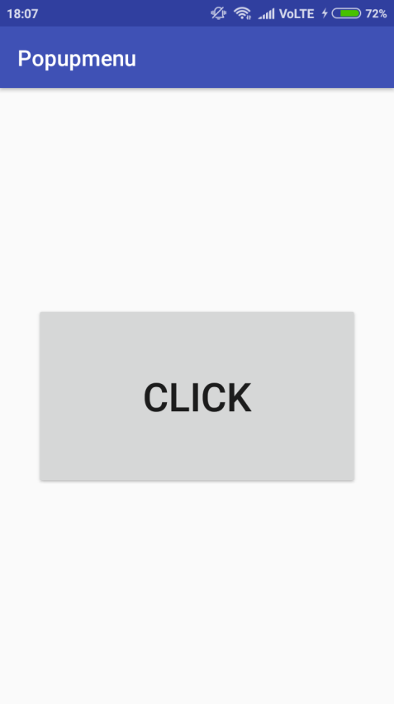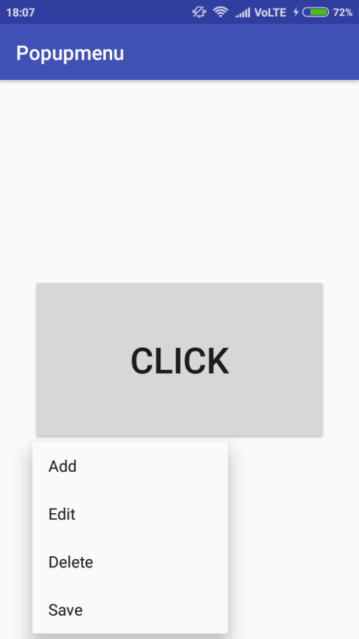
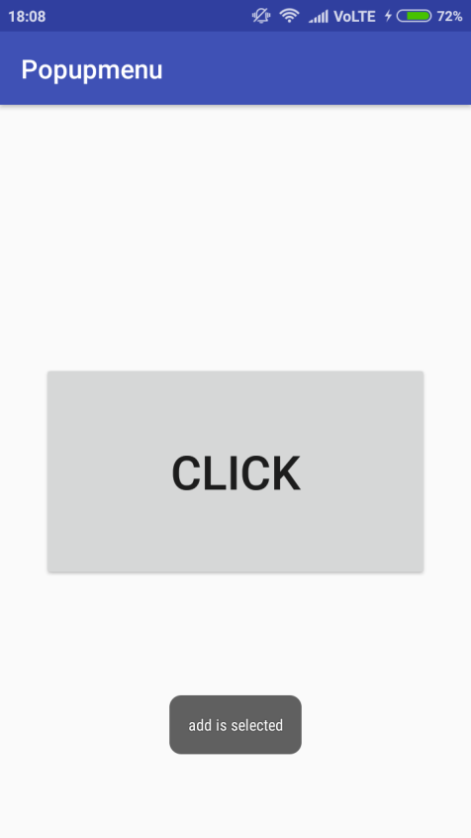

PRACTICAL 4
Aim: Program on Intents,Events,Listeners and Adapters
MainActivity.xml
<?xml version="1.0" encoding="utf-8"?>
<RelativeLayoutxmlns:android="http://schemas.android.com/apk/res/android"
xmlns:app="http://schemas.android.com/apk/res-auto"
xmlns:tools="http://schemas.android.com/tools"
android:layout_width="match_parent"
android:layout_height="match_parent"
tools:context=".MainActivity"
android:orientation="horizontal">
<AutoCompleteTextView
android:id="@+id/actv1"
android:layout_width="267dp"
android:layout_height="wrap_content"
android:layout_alignParentTop="true"
android:layout_centerHorizontal="true"
android:layout_marginTop="227dp"
android:contentDescription="enter name of sports" />
<Button
android:id="@+id/b1"
android:layout_width="wrap_content"
android:layout_height="wrap_content"
android:layout_alignParentBottom="true"
android:layout_centerHorizontal="true"
android:layout_marginBottom="210dp"
android:text="WIKI-SEARCH" />
<TextView
android:id="@+id/textView"
android:layout_width="226dp"
android:layout_height="wrap_content"
android:layout_alignParentTop="true"
android:layout_centerHorizontal="true"
android:layout_marginTop="165dp"
android:text="SEARCH FOR SPORTS DETAILS:"
android:textSize="20dp" />
</RelativeLayout>

MainActivity.java
package com.example.acer.demo;
import android.content.Intent;
import android.net.Uri;
import android.support.v7.app.AppCompatActivity;
import android.os.Bundle;
import android.view.View;
import android.widget.ArrayAdapter;
import android.widget.AutoCompleteTextView;
import android.widget.Button;
import android.widget.Toast;
public class MainActivityextendsAppCompatActivity {
AutoCompleteTextViewactv1;
Button b1;
ArrayAdapter<String>a;
String add;
String[] games=new String[]{"Football","Volleyball","Baseball","Batminton","Cricket","Hockey"};
@Override
protected void onCreate(Bundle savedInstanceState) {
super.onCreate(savedInstanceState);
setContentView(R.layout.activity_main);
actv1=(AutoCompleteTextView)findViewById(R.id.actv1);
b1=(Button)findViewById(R.id.b1);
a=new ArrayAdapter<String>(this,android.R.layout.simple_dropdown_item_1line,games);
actv1.setAdapter(a);
actv1.setThreshold(1);
b1.setOnClickListener(new View.OnClickListener() {
@Override
public void onClick(View view) {
add=actv1.getText().toString();
String url="https://en.wikipedia.org/wiki/" + add;
Toast.makeText(MainActivity.this,url,Toast.LENGTH_LONG).show();
Intent i = new Intent(Intent.ACTION_VIEW, Uri.parse(url));
startActivity(i);
}
});
}
}

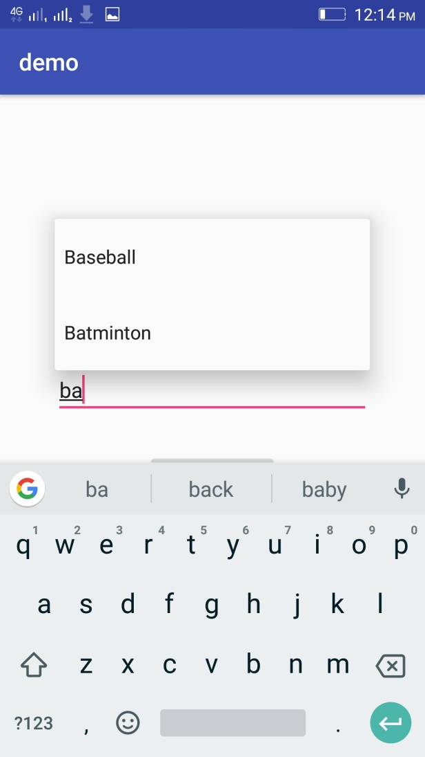
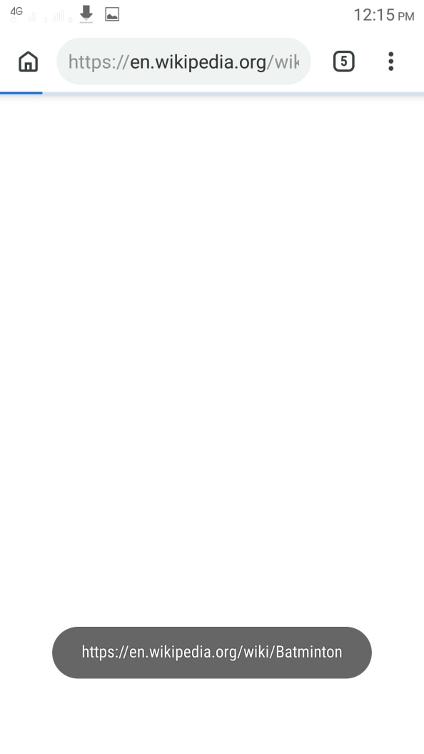

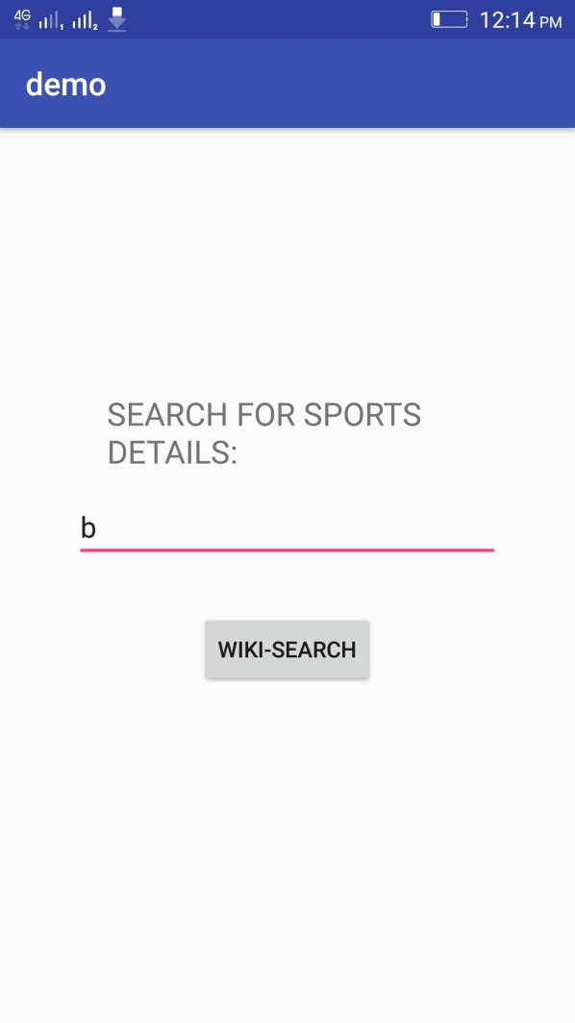

B] screen navigation
Xmlfile
<?xml version="1.0" encoding="utf-8"?>
<RelativeLayoutxmlns:android="http://schemas.android.com/apk/res/android"
xmlns:tools="http://schemas.android.com/tools"
android:layout_width="match_parent"
android:layout_height="match_parent"
android:paddingBottom="@dimen/activity_vertical_margin"
android:paddingLeft="@dimen/activity_horizontal_margin"
android:paddingRight="@dimen/activity_horizontal_margin"
android:paddingTop="@dimen/activity_vertical_margin"
tools:context="com.example.sys.myapplication.MainActivity">
<Button
android:layout_width="wrap_content"
android:layout_height="wrap_content"
android:text="New Button"
android:id="@+id/button"
android:layout_centerVertical="true"
android:layout_centerHorizontal="true" />
</RelativeLayout>
Javafile
Mainactivity.java
package com.example.sys.myapplication;
import android.content.Intent;
import android.support.v7.app.AppCompatActivity;
import android.os.Bundle;
import android.view.View;
import android.widget.Button;
public class MainActivityextends AppCompatActivity {
@Override
protected void onCreate(Bundle savedInstanceState) {
super.onCreate(savedInstanceState);
setContentView(R.layout.activity_main);
Button b1;
b1=(Button)findViewById(R.id.button);
b1.setOnClickListener(new View.OnClickListener() {
@Override
public void onClick(View view) {
Intent intent=new Intent(MainActivity.this,secondactivity.class);
startActivity(intent);
}
});
}
}

secondactivity.java
package com.example.sys.myapplication;
import android.support.v7.app.AppCompatActivity;
import android.os.Bundle;
public class secondactivityextends AppCompatActivity {
@Override
protected void onCreate(Bundle savedInstanceState) {
super.onCreate(savedInstanceState);
setContentView(R.layout.activity_secondactivity);
getSupportActionBar().setTitle("activity2");
getSupportActionBar().setDisplayHomeAsUpEnabled(true);
}}
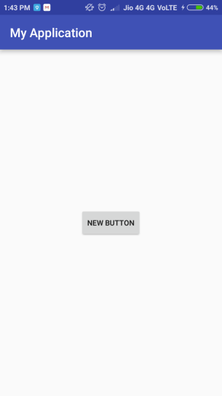
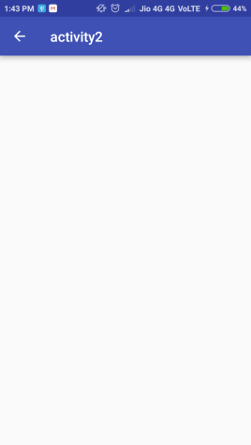

practical 5
Aim: Programs on Broadcast Receivers, Notifications and Services

A)use of Broadcast receivers
Xmlfile
<?xml version="1.0" encoding="utf-8"?>
<android.support.constraint.ConstraintLayoutxmlns:android="http://schemas.android.com/apk/res/android"
xmlns:app="http://schemas.android.com/apk/res-auto"
xmlns:tools="http://schemas.android.com/tools"
android:layout_width="match_parent"
android:layout_height="match_parent"
tools:context="com.example.ashok.myapplication.MainActivity">
<TextView
android:id="@+id/textfield"
android:layout_width="193dp"
android:layout_height="100dp"
android:layout_gravity="center"
app:layout_constraintBottom_toBottomOf="parent"
app:layout_constraintHorizontal_bias="0.502"
app:layout_constraintLeft_toLeftOf="parent"
app:layout_constraintRight_toRightOf="parent"
app:layout_constraintTop_toTopOf="parent"
app:layout_constraintVertical_bias="0.153" />
<ProgressBar
android:id="@+id/progressbar"
style="?android:attr/progressBarStyleHorizontal"
android:layout_width="wrap_content"
android:layout_height="wrap_content"
android:layout_gravity="center"
android:max="100"
android:minHeight="100dip"
android:minWidth="200dip"
app:layout_constraintBottom_toBottomOf="parent"
app:layout_constraintLeft_toLeftOf="parent"
app:layout_constraintRight_toRightOf="parent"
app:layout_constraintTop_toTopOf="parent"
app:layout_constraintVertical_bias="0.498" />
</android.support.constraint.ConstraintLayout>

Javafile
package com.example.ashok.myapplication;
import android.content.BroadcastReceiver;
import android.content.Context;
import android.content.Intent;
import android.content.IntentFilter;
import android.support.v7.app.AppCompatActivity;
import android.os.Bundle;
import android.widget.ProgressBar;
import android.widget.TextView;
public class MainActivityextends AppCompatActivity {
BroadcastReceiverbroadcastReceiver=new BroadcastReceiver() {
@Override
public void onReceive(Context context, Intent intent) {
int level=intent.getIntExtra("level",0);
ProgressBarprogressBar=(ProgressBar)findViewById(R.id.progressbar);
progressBar.setProgress(level);
TextView tv=(TextView)findViewById(R.id.textfield);
tv.setText("Battery Level: " + Integer.toString(level) + "%");
}
};
@Override
protected void onCreate(Bundle savedInstanceState) {
super.onCreate(savedInstanceState);
setContentView(R.layout.activity_main);
registerReceiver(broadcastReceiver, new IntentFilter(
Intent.ACTION_BATTERY_CHANGED));
}
}
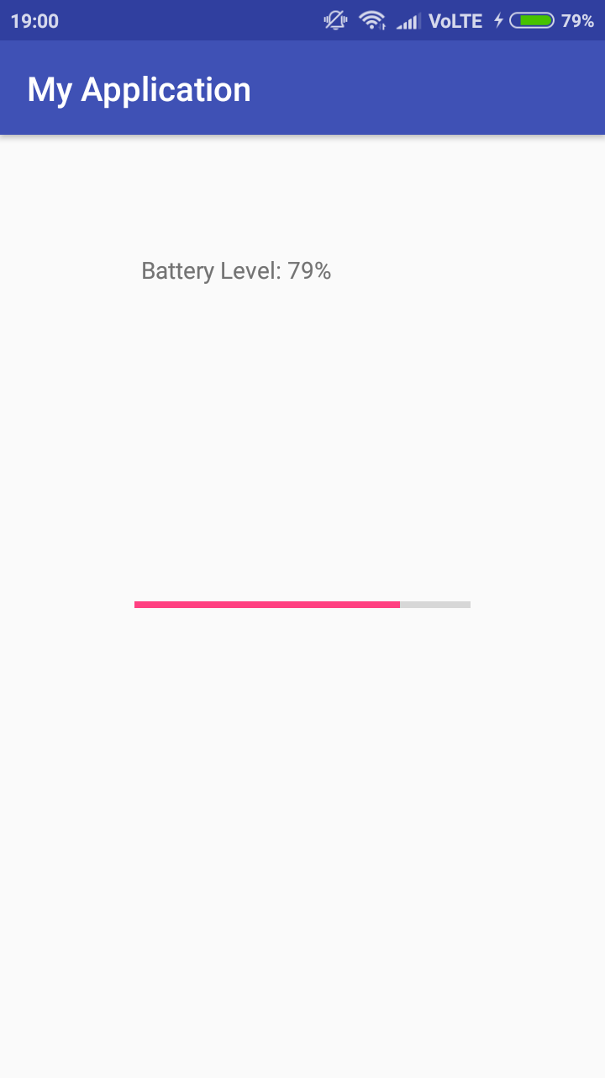

B)notifications
Xmlfile
<android.support.constraint.ConstraintLayoutxmlns:android="http://schemas.android.com/apk/res/android"
xmlns:app="http://schemas.android.com/apk/res-auto"
xmlns:tools="http://schemas.android.com/tools"
android:layout_width="match_parent"
android:layout_height="match_parent"
tools:context="com.example.ashok.myapplication.MainActivity">
<Button
android:id="@+id/button"
android:layout_width="158dp"
android:layout_height="93dp"
android:onClick="sendnotification"
android:text="Click"
app:layout_constraintBottom_toBottomOf="parent"
app:layout_constraintLeft_toLeftOf="parent"
app:layout_constraintRight_toRightOf="parent"
app:layout_constraintTop_toTopOf="parent"
app:layout_constraintVertical_bias="0.686" />
</android.support.constraint.ConstraintLayout>
Javafile
package com.example.ashok.myapplication;
import android.support.v7.app.AppCompatActivity;
import android.os.Bundle;
import android.app.NotificationManager;
import android.support.v4.app.NotificationCompat;
import android.view.View;
import android.content.Context;
public class MainActivityextends AppCompatActivity {
@Override
protected void onCreate(Bundle savedInstanceState) {
super.onCreate(savedInstanceState);
setContentView(R.layout.activity_main);
}
public void sendNotification(View view) {
NotificationCompat.BuildermBuilder =new NotificationCompat.Builder(this).setSmallIcon(R.drawable.notification_icon)
.setContentTitle("My notification").setContentText("Hello World!");
NotificationManagermNotificationManager =(NotificationManager) getSystemService(Context.NOTIFICATION_SERVICE);
NotificationManager.notify().
mNotificationManager.notify(001, mBuilder.build());
}
}
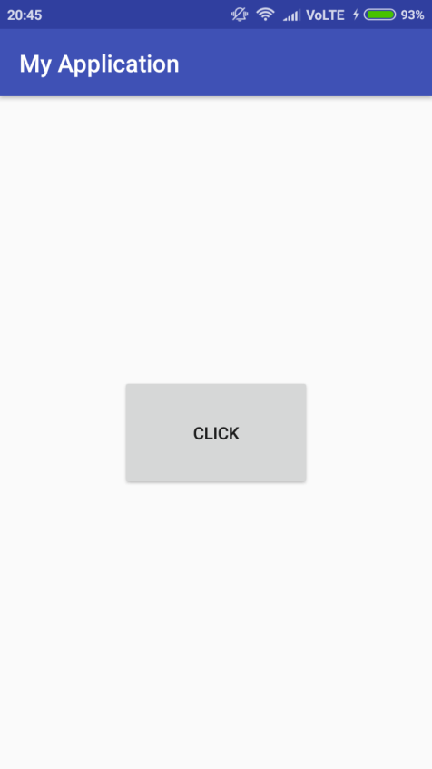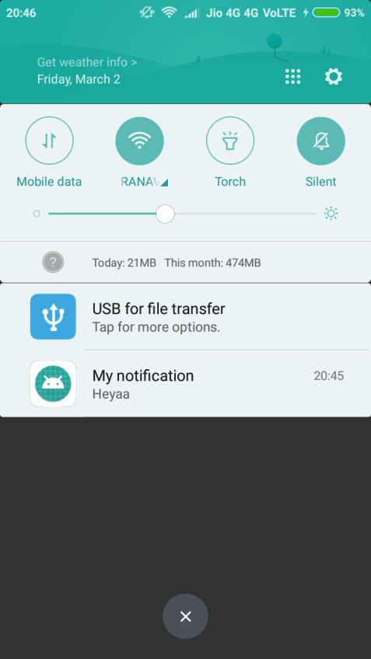

C)SERVICES

activity.xml
<?xml version="1.0" encoding="utf-8"?>
<RelativeLayoutxmlns:android="http://schemas.android.com/apk/res/android"
xmlns:tools="http://schemas.android.com/tools"
android:id="@+id/activity_main"
android:layout_width="match_parent"
android:layout_height="match_parent"
android:paddingBottom="@dimen/activity_vertical_margin"
android:paddingLeft="@dimen/activity_horizontal_margin"
android:paddingRight="@dimen/activity_horizontal_margin"
android:paddingTop="@dimen/activity_vertical_margin"
tools:context="com.v.sound.MainActivity">
<TextView
android:layout_width="wrap_content"
android:layout_height="wrap_content"
android:text="Hello World!"
android:id="@+id/textView" />
<Button
android:text="Start Music"
android:layout_width="wrap_content"
android:layout_height="wrap_content"
android:layout_below="@+id/textView"
android:layout_toRightOf="@+id/textView"
android:layout_toEndOf="@+id/textView"
android:layout_marginTop="101dp"
android:id="@+id/btnStart"
android:onClick="musicStart"/>
<Button
android:text="Stop music"
android:layout_width="wrap_content"
android:layout_height="wrap_content"
android:layout_centerVertical="true"
android:layout_alignRight="@+id/btnStart"
android:layout_alignEnd="@+id/btnStart"
android:id="@+id/btnStop"
android:layout_alignLeft="@+id/btnStart"
android:layout_alignStart="@+id/btnStart"
android:onClick="musicStop"/>
</RelativeLayout>
myActivity.java
package com.v.sound;
import android.content.Intent;
import android.media.MediaPlayer;
import android.support.v7.app.AppCompatActivity;
import android.os.Bundle;
import android.view.View;
public class MainActivityextends AppCompatActivity {
Intent i;
@Override
protected void onCreate(Bundle savedInstanceState) {
super.onCreate(savedInstanceState);
setContentView(R.layout.activity_main);
}
public void musicStart(View view)
{
i=new Intent(MainActivity.this,MyService.class);
startService(i);
}
public void musicStop(View view)
{
stopService(i);
}
}

MyService.java
package com.v.sound;
import android.app.Service;
import android.content.Intent;
import android.media.MediaPlayer;
import android.os.IBinder;
import android.support.annotation.Nullable;
/**
* Created by lab1_pc11 on 12/28/2016.
*/
public class MyServiceextends Service {
MediaPlayermediaPlayer;
@Nullable
@Override
public IBinderonBind(Intent intent) {
return null;
}
@Override
public int onStartCommand(Intent intent, int flags, int startId) {
mediaPlayer=MediaPlayer.create(getApplicationContext(),R.raw.kalimba);
mediaPlayer.start();
return super.onStartCommand(intent, flags, startId);
}
@Override
public void onDestroy() {
super.onDestroy();
mediaPlayer.stop();
}
}

androidmanifest.xml
<?xml version="1.0" encoding="utf-8"?>
<manifest xmlns:android="http://schemas.android.com/apk/res/android"
package="com.v.sound">
<application
android:allowBackup="true"
android:icon="@mipmap/ic_launcher"
android:label="@string/app_name"
android:supportsRtl="true"
android:theme="@style/AppTheme">
<activity android:name=".MainActivity">
<intent-filter>
<action android:name="android.intent.action.MAIN" />
<category android:name="android.intent.category.LAUNCHER" />
</intent-filter>
</activity>
<service android:name=".MyService"/>
</application>
</manifest>

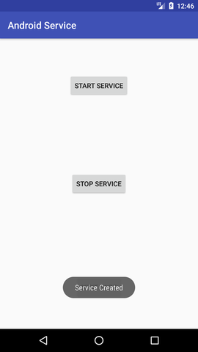
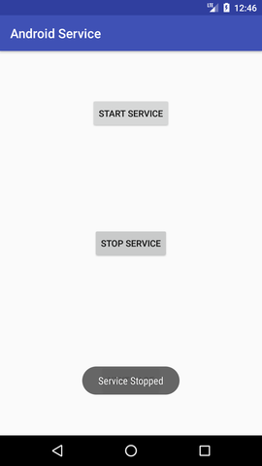

practical 6
Aim: Programs on SQLite Database
activity_main.xml

<RelativeLayoutxmlns:android="http://schemas.android.com/apk/res/android"
xmlns:tools="http://schemas.android.com/tools" android:layout_width="match_parent"
android:layout_height="match_parent"
tools:context=".MainActivity">
<TextView
android:layout_width="wrap_content"
android:layout_height="wrap_content"
android:textAppearance="?android:attr/textAppearanceLarge"
android:text="Name"
android:id="@+id/textView"
android:layout_alignParentTop="true"
android:layout_alignParentLeft="true"
android:layout_alignParentStart="true" />
<TextView
android:layout_width="wrap_content"
android:layout_height="wrap_content"
android:textAppearance="?android:attr/textAppearanceLarge"
android:text="Surname"
android:id="@+id/textView2"
android:layout_below="@+id/editText_name"
android:layout_alignParentLeft="true"
android:layout_alignParentStart="true" />
<TextView
android:layout_width="wrap_content"
android:layout_height="wrap_content"
android:textAppearance="?android:attr/textAppearanceLarge"
android:text="Marks"
android:id="@+id/textView3"
android:layout_below="@+id/editText_surname"
android:layout_alignParentLeft="true"
android:layout_alignParentStart="true" />
<EditText
android:layout_width="match_parent"
android:layout_height="wrap_content"
android:id="@+id/editText_name"
android:layout_alignTop="@+id/textView"
android:layout_toRightOf="@+id/textView"
android:layout_toEndOf="@+id/textView" />
<EditText
android:layout_width="match_parent"
android:layout_height="wrap_content"
android:id="@+id/editText_surname"
android:layout_alignTop="@+id/textView2"
android:layout_toRightOf="@+id/textView2"
android:layout_toEndOf="@+id/textView2" />
<EditText
android:layout_width="match_parent"
android:layout_height="wrap_content"
android:id="@+id/editText_Marks"
android:layout_below="@+id/editText_surname"
android:layout_toRightOf="@+id/textView3"
android:layout_toEndOf="@+id/textView3" />
<Button
android:id="@+id/button_add"
android:layout_width="match_parent"
android:layout_height="wrap_content"
android:layout_alignParentBottom="true"
android:layout_centerHorizontal="true"
android:layout_marginBottom="232dp"
android:text="Add Data" />
<Button
android:id="@+id/button_viewAll"
android:layout_width="match_parent"
android:layout_height="wrap_content"
android:layout_alignParentBottom="true"
android:layout_alignParentStart="true"
android:layout_marginBottom="174dp"
android:text="View All" />
<Button
android:id="@+id/button_update"
android:layout_width="match_parent"
android:layout_height="wrap_content"
android:layout_alignParentBottom="true"
android:layout_alignParentStart="true"
android:layout_marginBottom="112dp"
android:text="Update" />
<Button
android:id="@+id/button_delete"
android:layout_width="match_parent"
android:layout_height="wrap_content"
android:layout_alignParentBottom="true"
android:layout_alignParentStart="true"
android:layout_marginBottom="52dp"
android:text="Delete" />
<TextView
android:layout_width="wrap_content"
android:layout_height="wrap_content"
android:textAppearance="?android:attr/textAppearanceLarge"
android:text="id"
android:id="@+id/textView_id"
android:layout_below="@+id/editText_Marks"
android:layout_alignParentLeft="true"
android:layout_alignParentStart="true" />
<EditText
android:layout_width="match_parent"
android:layout_height="wrap_content"
android:id="@+id/editText_id"
android:layout_alignTop="@+id/textView_id"
android:layout_toRightOf="@+id/textView3"
android:layout_toEndOf="@+id/textView3" />
</RelativeLayout>

MainActivity.java

package com.example.acer.sqllitedbex;

import android.app.AlertDialog;
import android.database.Cursor;
import android.support.v7.app.AppCompatActivity;
import android.os.Bundle;
import android.view.Menu;
import android.view.MenuItem;
import android.view.View;
import android.widget.Button;
import android.widget.EditText;
import android.widget.Toast;

public class MainActivityextends AppCompatActivity {

DatabaseHelpermyDb;
EditTexteditName,editSurname,editMarks,editTextId;
Button btnAddData;
Button btnviewAll;
Button btnDelete;

Button btnviewUpdate;

@Override
protected void onCreate(Bundle savedInstanceState) {
super.onCreate(savedInstanceState);
setContentView(R.layout.activity_main);

myDb= new DatabaseHelper(this);

editName= (EditText)findViewById(R.id.editText_name);
editSurname= (EditText)findViewById(R.id.editText_surname);
editMarks= (EditText)findViewById(R.id.editText_Marks);
editTextId= (EditText)findViewById(R.id.editText_id);
btnAddData= (Button)findViewById(R.id.button_add);
btnviewAll= (Button)findViewById(R.id.button_viewAll);
btnviewUpdate= (Button)findViewById(R.id.button_update);
btnDelete= (Button)findViewById(R.id.button_delete);
AddData();
viewAll();
UpdateData();
DeleteData();
}

public void DeleteData() {
btnDelete.setOnClickListener(
new View.OnClickListener() {
@Override
public void onClick(View v) {
Integer deletedRows = myDb.deleteData(editTextId.getText().toString());
if(deletedRows>0)
Toast.makeText(MainActivity.this,"Data Deleted",Toast.LENGTH_LONG).show();
else
Toast.makeText(MainActivity.this,"Data not Deleted",Toast.LENGTH_LONG).show();
}
}
);
}
public void UpdateData() {
btnviewUpdate.setOnClickListener(
new View.OnClickListener() {
@Override
public void onClick(View v) {
booleanisUpdate = myDb.updateData(editTextId.getText().toString(),
editName.getText().toString(),
editSurname.getText().toString(),editMarks.getText().toString());
if(isUpdate == true)
Toast.makeText(MainActivity.this,"Data Update",Toast.LENGTH_LONG).show();
else
Toast.makeText(MainActivity.this,"Data not Updated",Toast.LENGTH_LONG).show();
}
}
);
}
public voidAddData() {
btnAddData.setOnClickListener(
new View.OnClickListener() {
@Override
public void onClick(View v) {
booleanisInserted = myDb.insertData(editName.getText().toString(),
editSurname.getText().toString(),
editMarks.getText().toString() );
if(isInserted == true)
Toast.makeText(MainActivity.this,"Data Inserted",Toast.LENGTH_LONG).show();
else
Toast.makeText(MainActivity.this,"Data not Inserted",Toast.LENGTH_LONG).show();
}
}
);
}

public void viewAll() {
btnviewAll.setOnClickListener(
new View.OnClickListener() {
@Override
public void onClick(View v) {
Cursor res = myDb.getAllData();
if(res.getCount() == 0) {
// show message
showMessage("Error","Nothing found");
return;
}

StringBuffer buffer = new StringBuffer();
while (res.moveToNext()) {
buffer.append("Id :"+ res.getString(0)+"\n");
buffer.append("Name :"+ res.getString(1)+"\n");
buffer.append("Surname :"+ res.getString(2)+"\n");
buffer.append("Marks :"+ res.getString(3)+"\n\n");
}

// Show all data
showMessage("Data",buffer.toString());
}
}
);
}

public void showMessage(String title,String Message){
AlertDialog.Builder builder = new AlertDialog.Builder(this);
builder.setCancelable(true);
builder.setTitle(title);
builder.setMessage(Message);
builder.show();
}

@Override
public booleanonCreateOptionsMenu(Menu menu) {
// Inflate the menu; this adds items to the action bar if it is present.
getMenuInflater().inflate(R.menu.menu_main, menu);
return true;
}

@Override
public booleanonOptionsItemSelected(MenuItem item) {
// Handle action bar item clicks here. The action bar will
// automatically handle clicks on the Home/Up button, so long
// as you specify a parent activity in AndroidManifest.xml.
int id = item.getItemId();

return super.onOptionsItemSelected(item);
}}

DatabaseHelper.java

package com.example.acer.sqllitedbex;

import android.content.ContentValues;
import android.content.Context;
import android.database.Cursor;
import android.database.sqlite.SQLiteDatabase;
import android.database.sqlite.SQLiteOpenHelper;

public class DatabaseHelperextends SQLiteOpenHelper {
public static final String DATABASE_NAME = "Student.db";
public static final String TABLE_NAME = "student_table";
public static final String COL_1 = "ID";
public static final String COL_2 = "NAME";
public static final String COL_3 = "SURNAME";
public static final String COL_4 = "MARKS";

public DatabaseHelper(Context context) {
super(context, DATABASE_NAME, null, 1);
}

@Override
public void onCreate(SQLiteDatabasedb) {
db.execSQL("create table " + TABLE_NAME +" (ID INTEGER PRIMARY KEY AUTOINCREMENT,NAME TEXT,SURNAME TEXT,MARKS INTEGER)");
}

@Override
public void onUpgrade(SQLiteDatabasedb, int oldVersion, int newVersion) {
db.execSQL("DROP TABLE IF EXISTS "+TABLE_NAME);
onCreate(db);
}

public booleaninsertData(String name,Stringsurname,String marks) {
SQLiteDatabasedb = this.getWritableDatabase();
ContentValuescontentValues = new ContentValues();
contentValues.put(COL_2,name);
contentValues.put(COL_3,surname);
contentValues.put(COL_4,marks);
long result = db.insert(TABLE_NAME,null,contentValues);
if(result == -1)
return false;
else
return true;
}

public Cursor getAllData() {
SQLiteDatabasedb = this.getWritableDatabase();
Cursor res = db.rawQuery("select * from "+TABLE_NAME,null);
return res;
}

public booleanupdateData(String id,Stringname,Stringsurname,String marks) {
SQLiteDatabasedb = this.getWritableDatabase();
ContentValuescontentValues = new ContentValues();
contentValues.put(COL_1,id);
contentValues.put(COL_2,name);
contentValues.put(COL_3,surname);
contentValues.put(COL_4,marks);
db.update(TABLE_NAME, contentValues, "ID = ?",new String[] { id });
return true;
}

public Integer deleteData (String id) {
SQLiteDatabasedb = this.getWritableDatabase();
return db.delete(TABLE_NAME, "ID = ?",new String[] {id});
}
}
Output
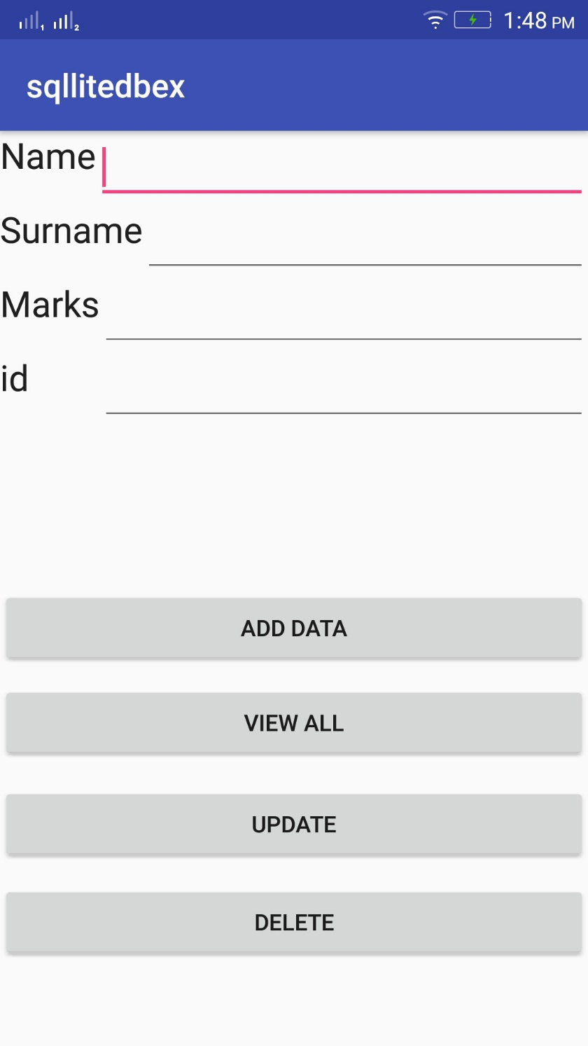
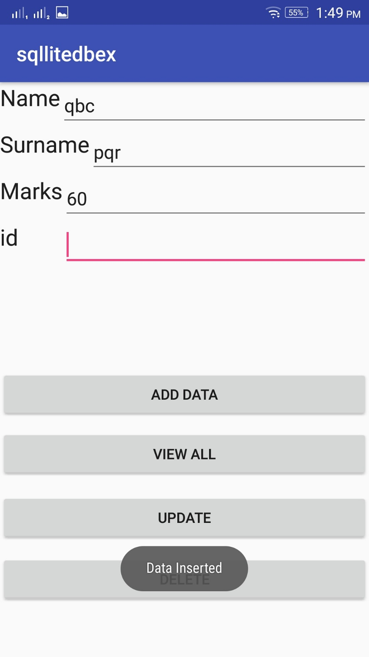
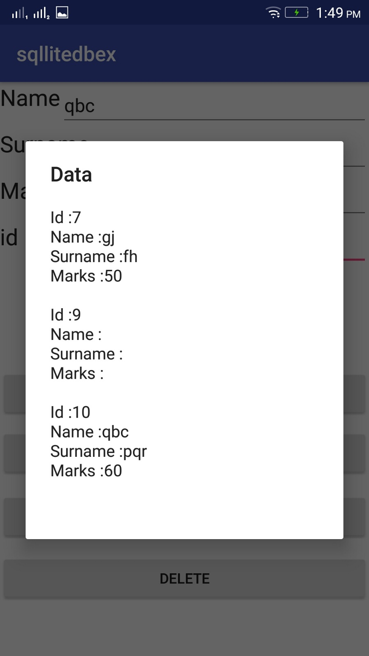

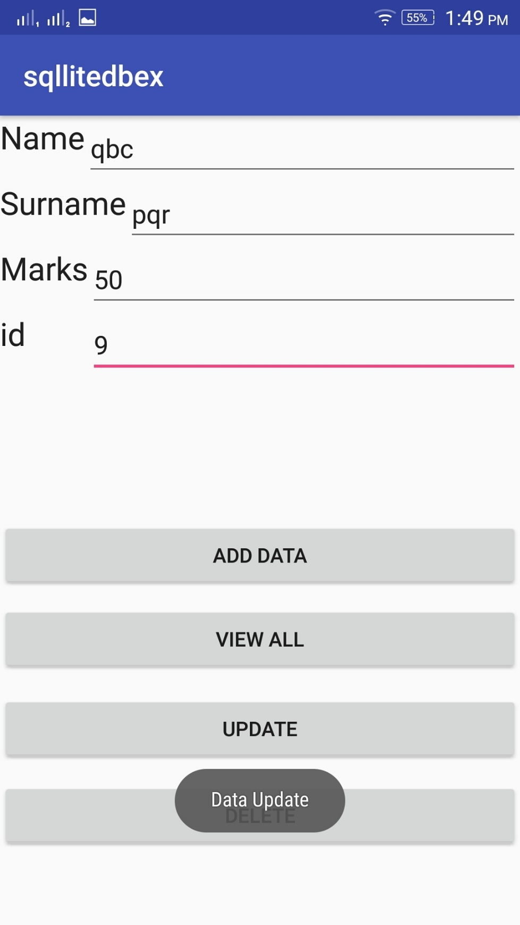
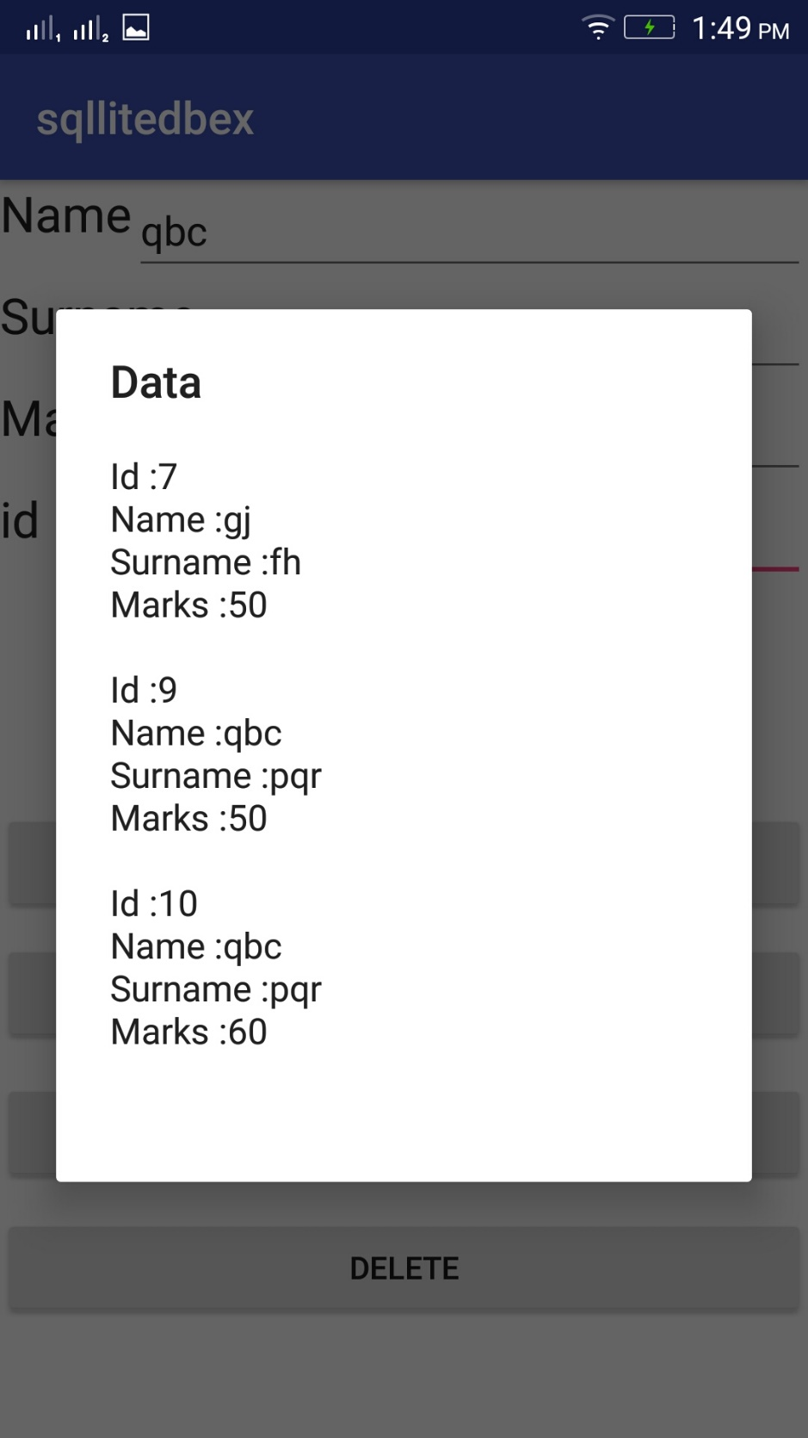

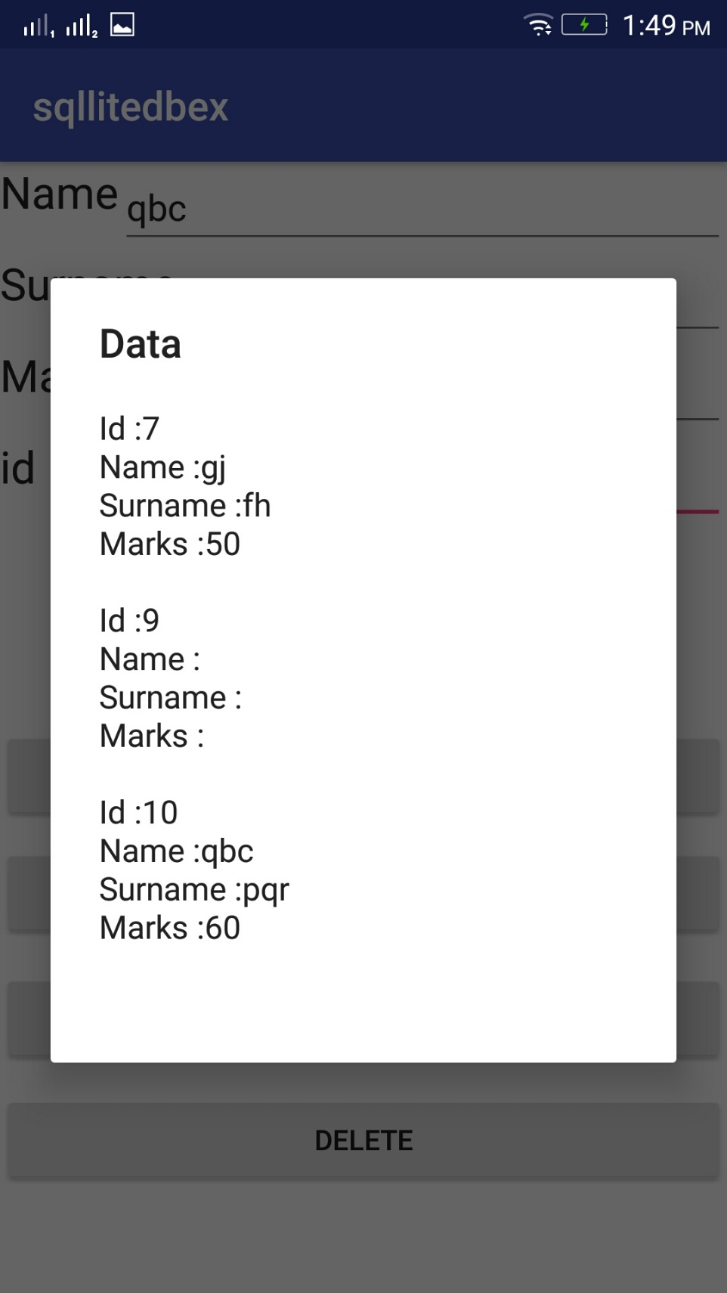

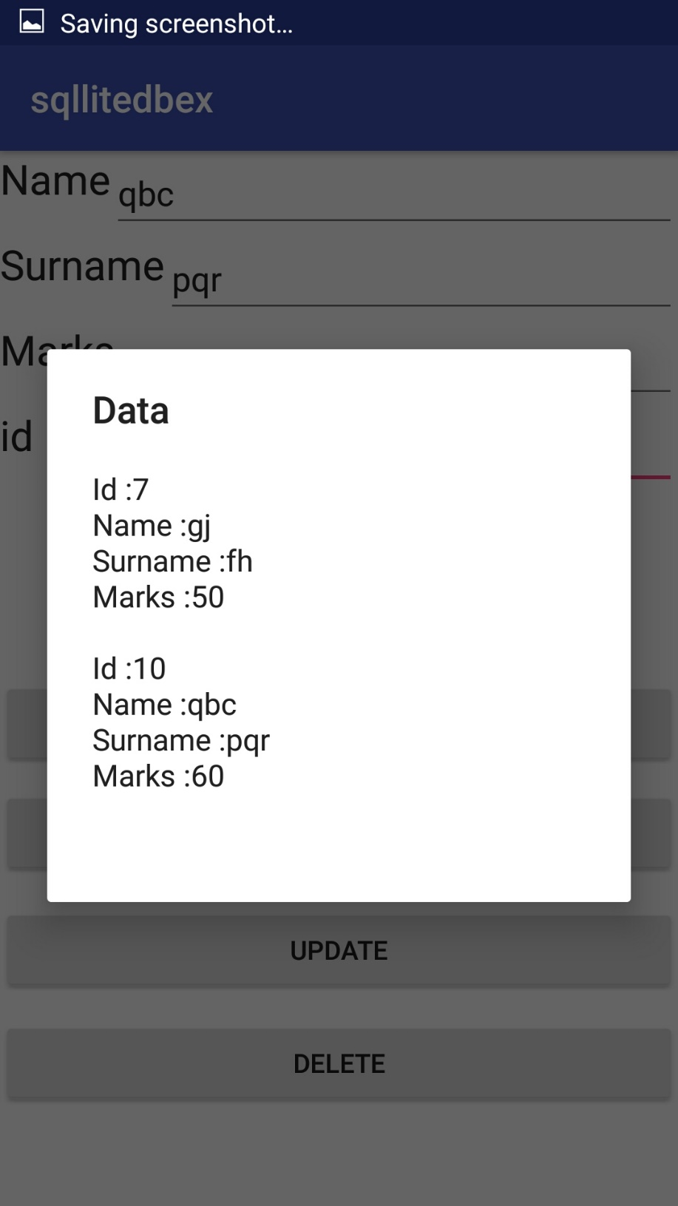

practical 7
Aim: Programs on Media and Telephony API
A]Camera

AndroidManifest.xml
<?xml version="1.0" encoding="utf-8"?>
<manifest xmlns:android="http://schemas.android.com/apk/res/android"
package="com.example.camera">
<uses-feature
android:name="android.hardware.Camera"
android:required="true"></uses-feature>
<application
android:allowBackup="true"
android:icon="@mipmap/ic_launcher"
android:label="@string/app_name"
android:roundIcon="@mipmap/ic_launcher_round"
android:supportsRtl="true"
android:theme="@style/AppTheme">
<activity android:name=".MainActivity">
<intent-filter>
<action android:name="android.intent.action.MAIN" />
<category android:name="android.intent.category.LAUNCHER" />
</intent-filter>
</activity>
</application>
</manifest>

activity_main.xml

<?xml version="1.0" encoding="utf-8"?>
<RelativeLayoutxmlns:android="http://schemas.android.com/apk/res/android"
xmlns:app="http://schemas.android.com/apk/res-auto"
xmlns:tools="http://schemas.android.com/tools"
android:layout_width="match_parent"
android:layout_height="match_parent"
tools:context=".MainActivity">

<Button
android:id="@+id/button"
android:layout_width="wrap_content"
android:layout_height="wrap_content"
android:text="Capture Pic"
android:layout_marginTop="200dp"
android:onClick="takepicture"
android:layout_centerHorizontal="true"/>

<ImageView
android:id="@+id/imageView"
android:layout_width="250dp"
android:layout_height="200dp"
app:srcCompat="@mipmap/ic_launcher"
android:layout_marginTop="25dp"
android:layout_centerHorizontal="true"
android:layout_below="@id/button"/>
</RelativeLayout>

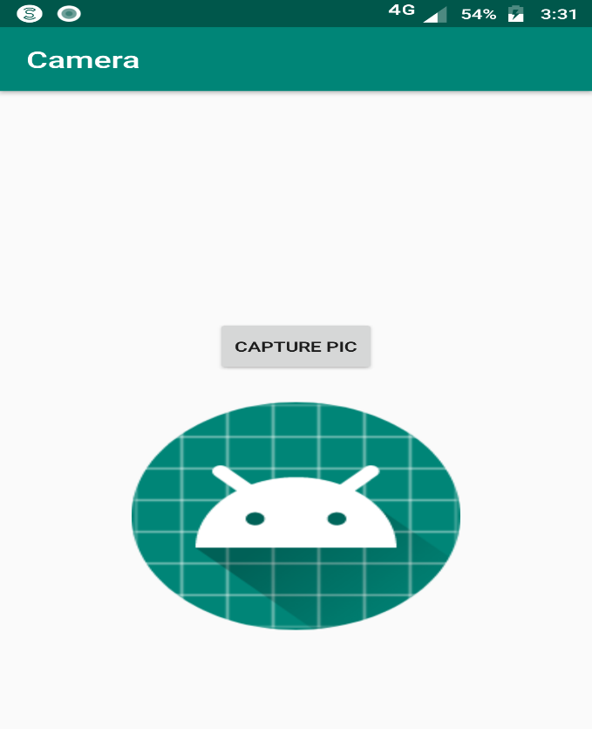

MainActivity.java
package com.example.camera;

import android.content.Intent;
import android.graphics.Bitmap;
import android.provider.MediaStore;
import android.support.annotation.Nullable;
import android.support.v7.app.AppCompatActivity;
import android.os.Bundle;
import android.view.View;
import android.widget.ImageView;

public class MainActivityextends AppCompatActivity {

private ImageViewmimageView;
private static final int REQUEST_IMAGE_CAPTURE= 101;

@Override
protected void onCreate(Bundle savedInstanceState) {
super.onCreate(savedInstanceState);
setContentView(R.layout.activity_main);

mimageView=(ImageView)findViewById(R.id.imageView);
}

public void takepicture(View view) {

Intent intent = new Intent(MediaStore.ACTION_IMAGE_CAPTURE);

if (intent.resolveActivity(getPackageManager())!=null)
{
startActivityForResult(intent,REQUEST_IMAGE_CAPTURE);
}
}

@Override
protected void onActivityResult(int requestCode, int resultCode, @Nullable Intent data) {
if (requestCode==REQUEST_IMAGE_CAPTURE &&resultCode==RESULT_OK)
{
Bundle bundle = data.getExtras();
Bitmap bitmap = (Bitmap) bundle.get("data");
mimageView.setImageBitmap(bitmap);
}
}
}

Output:
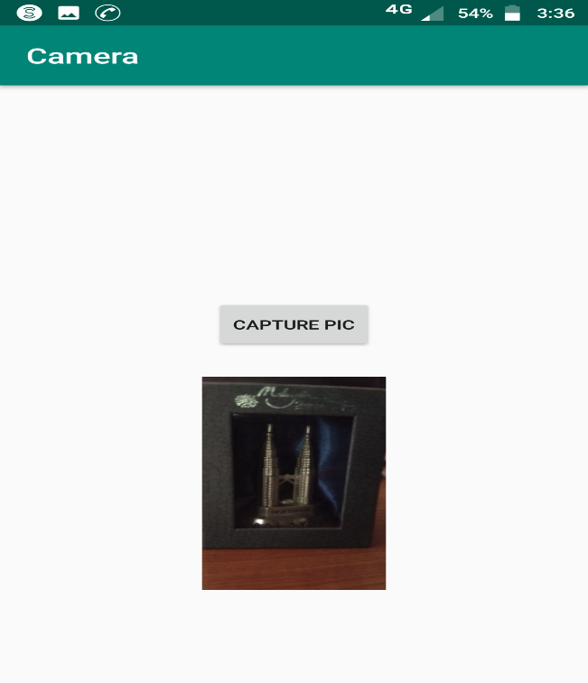

B] Telephone API
AndroidManifest.xml
<?xml version="1.0" encoding="utf-8"?>
<manifest xmlns:android="http://schemas.android.com/apk/res/android"
package="com.example.callphone">

<application
android:allowBackup="true"
android:icon="@mipmap/ic_launcher"
android:label="@string/app_name"
android:roundIcon="@mipmap/ic_launcher_round"
android:supportsRtl="true"
android:theme="@style/AppTheme">
<activity android:name=".MainActivity">
<intent-filter>
<action android:name="android.intent.action.MAIN" />

<category android:name="android.intent.category.LAUNCHER" />
</intent-filter>
</activity>
</application>

<uses-permission android:name="android.permission.CALL_PHONE" />

</manifest>

Output: -

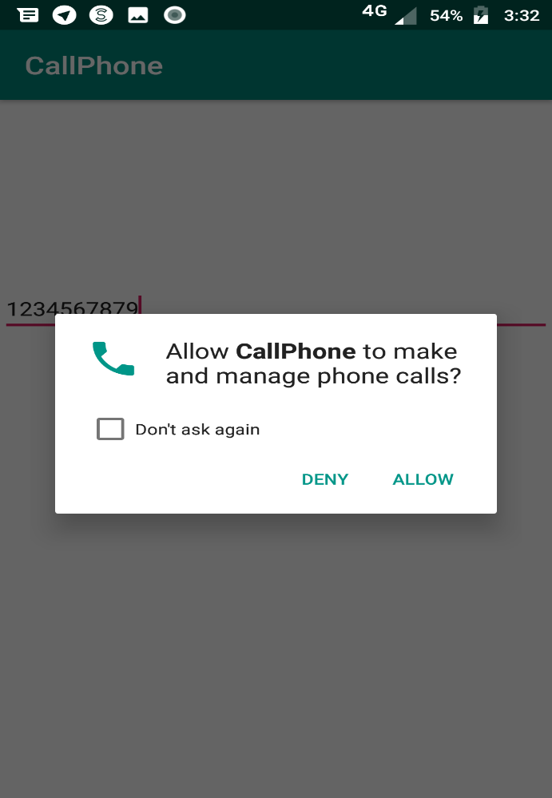

activity_main.xml
<?xml version="1.0" encoding="utf-8"?>
<RelativeLayoutxmlns:android="http://schemas.android.com/apk/res/android"
xmlns:app="http://schemas.android.com/apk/res-auto"
xmlns:tools="http://schemas.android.com/tools"
android:layout_width="match_parent"
android:layout_height="match_parent"
tools:context=".MainActivity">

<EditText
android:id="@+id/edit_text_number"
android:layout_width="match_parent"
android:layout_height="wrap_content"
android:layout_alignParentTop="true"
android:layout_marginTop="147dp"
android:inputType="phone" />

<ImageView
android:id="@+id/image_call"
android:layout_width="80dp"
android:layout_height="80dp"
android:layout_centerHorizontal="true"
android:layout_centerVertical="true"
android:src="@drawable/ic_phone" />

</RelativeLayout>

Output: -

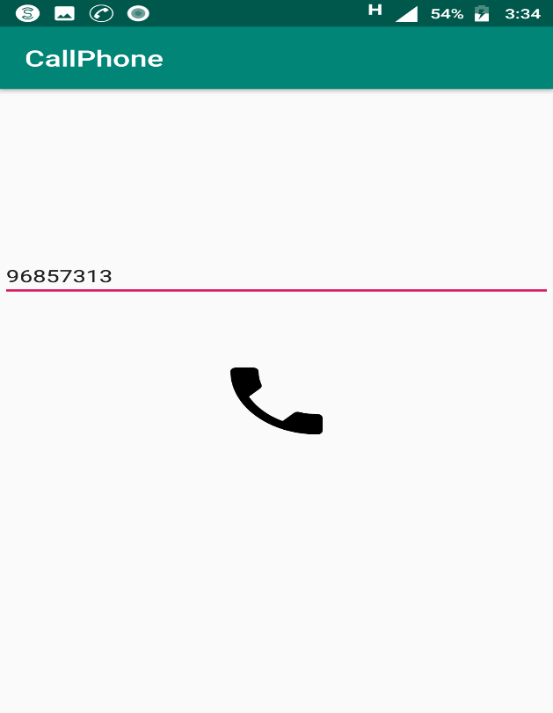
MainActivity.java

package com.example.callphone;

import android.Manifest;
import android.content.Intent;
import android.content.pm.PackageManager;
import android.net.Uri;
import android.support.annotation.NonNull;
import android.support.v4.app.ActivityCompat;
import android.support.v4.content.ContextCompat;
import android.support.v7.app.AppCompatActivity;
import android.os.Bundle;
import android.view.View;
import android.widget.EditText;
import android.widget.ImageView;
import android.widget.Toast;

public class MainActivityextends AppCompatActivity {
private static final int REQUEST_CALL = 1;
private EditTextmEditTextNumber;

@Override
protected void onCreate(Bundle savedInstanceState) {
super.onCreate(savedInstanceState);
setContentView(R.layout.activity_main);

mEditTextNumber= findViewById(R.id.edit_text_number);
ImageViewimageCall = findViewById(R.id.image_call);

imageCall.setOnClickListener(new View.OnClickListener() {
@Override
public void onClick(View v) {
makePhoneCall();
}
});
}

private void makePhoneCall() {
String number = mEditTextNumber.getText().toString();
if (number.trim().length() >0) {

if (ContextCompat.checkSelfPermission(MainActivity.this,
Manifest.permission.CALL_PHONE) != PackageManager.PERMISSION_GRANTED) {
ActivityCompat.requestPermissions(MainActivity.this,
new String[]{Manifest.permission.CALL_PHONE}, REQUEST_CALL);
} else {
String dial = "tel:" + number;
startActivity(new Intent(Intent.ACTION_CALL, Uri.parse(dial)));
}

} else {
Toast.makeText(MainActivity.this, "Enter Phone Number", Toast.LENGTH_SHORT).show();
}
}

@Override
public void onRequestPermissionsResult(int requestCode, @NonNullString[] permissions, @NonNullint[] grantResults) {
if (requestCode == REQUEST_CALL) {
if (grantResults.length>0 &&grantResults[0] == PackageManager.PERMISSION_GRANTED) {
makePhoneCall();
} else {
Toast.makeText(this, "Permission DENIED", Toast.LENGTH_SHORT).show();
}
}
}
}

Output: -
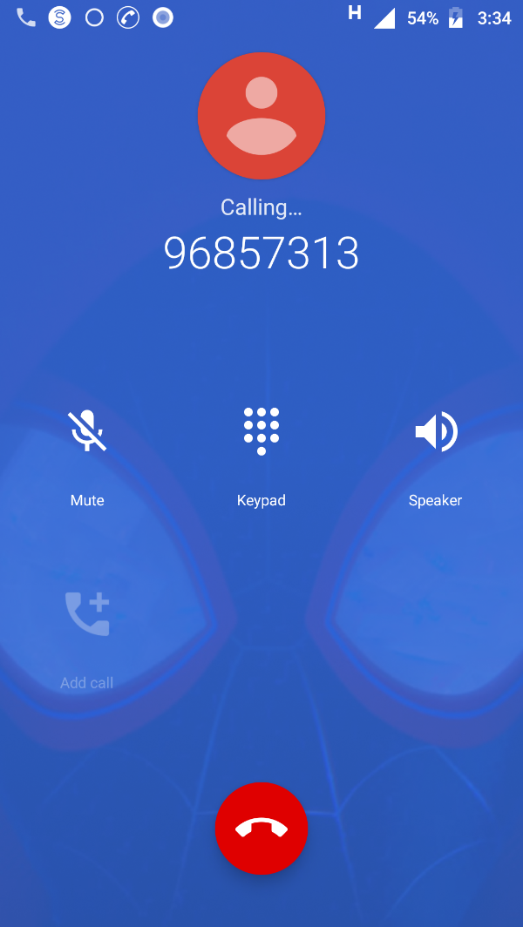

practical 8
Aim: Programs on Permissions and security

AndroidMainfest.xml

<?xml version="1.0" encoding="utf-8"?>
<manifest xmlns:android="http://schemas.android.com/apk/res/android"
package="com.example.request">
<uses-permission android:name="android.permission.READ_EXTERNAL_STORAGE"/>
<application
android:allowBackup="true"
android:icon="@mipmap/ic_launcher"
android:label="@string/app_name"
android:roundIcon="@mipmap/ic_launcher_round"
android:supportsRtl="true"
android:theme="@style/AppTheme">
<activity android:name=".MainActivity">
<intent-filter>
<action android:name="android.intent.action.MAIN" />
<category android:name="android.intent.category.LAUNCHER" />
</intent-filter>
</activity>
</application>
</manifest>

activity_main.xml
<?xml version="1.0" encoding="utf-8"?>
<RelativeLayout xmlns:android="http://schemas.android.com/apk/res/android"
xmlns:app="http://schemas.android.com/apk/res-auto"
xmlns:tools="http://schemas.android.com/tools"
android:layout_width="match_parent"
android:layout_height="match_parent"
tools:context=".MainActivity">
<Button
android:id="@+id/button"
android:layout_width="wrap_content"
android:layout_height="wrap_content"
android:text="Request Permission"
android:layout_centerInParent="true"
app:layout_constraiantBottom_toBottomOf="parent"
app:layout_constraintLeft_toLeftOf="parent"
app:layout_constraintRight_toRightOf="parent"
app:layout_constraintTop_toTopOf="parent" />
</RelativeLayout>

MainActivity.java

package com.example.request;
import android.Manifest;
import android.app.AlertDialog;
import android.content.DialogInterface;
import android.content.pm.PackageManager;
import android.support.annotation.NonNull;
import android.support.v4.app.ActivityCompat;
import android.support.v4.content.ContextCompat;
import android.support.v7.app.AppCompatActivity;
import android.os.Bundle;
import android.view.View;
import android.widget.Button;
import android.widget.Toast;
public class MainActivity extends AppCompatActivity {
private int STORAGE_PERMISSION_CODE = 1;
@Override
protected void onCreate(Bundle savedInstanceState) {
super.onCreate(savedInstanceState);
setContentView(R.layout.activity_main);
Button buttonRequest = findViewById(R.id.button);
buttonRequest.setOnClickListener(new View.OnClickListener() {
@Override
public void onClick(View v) {
if (ContextCompat.checkSelfPermission(MainActivity.this,
Manifest.permission.READ_EXTERNAL_STORAGE) == PackageManager.PERMISSION_GRANTED) {
Toast.makeText(MainActivity.this, "You have already granted this permission!",
Toast.LENGTH_SHORT).show();
} else {
requestStoragePermission();
}
}
});
}
private void requestStoragePermission() {
if (ActivityCompat.shouldShowRequestPermissionRationale(this,
Manifest.permission.READ_EXTERNAL_STORAGE)) {
new AlertDialog.Builder(this)
.setTitle("Permission needed")
.setMessage("This permission is needed because of this and that")
.setPositiveButton("ok", new DialogInterface.OnClickListener() {
@Override
public void onClick(DialogInterface dialog, int which) {
ActivityCompat.requestPermissions(MainActivity.this,
new String[] {Manifest.permission.READ_EXTERNAL_STORAGE}, STORAGE_PERMISSION_CODE);
}
})
.setNegativeButton("cancel", new DialogInterface.OnClickListener() {
@Override
public void onClick(DialogInterface dialog, int which) {
dialog.dismiss();
}
})
.create().show();
} else {
ActivityCompat.requestPermissions(this,
new String[] {Manifest.permission.READ_EXTERNAL_STORAGE}, STORAGE_PERMISSION_CODE);
}
}
@Override
public void onRequestPermissionsResult(int requestCode, @NonNull String[] permissions, @NonNull int[] grantResults) {
if (requestCode == STORAGE_PERMISSION_CODE) {
if (grantResults.length >0 && grantResults[0] == PackageManager.PERMISSION_GRANTED) {
Toast.makeText(this, "Permission GRANTED", Toast.LENGTH_SHORT).show();
} else {
Toast.makeText(this, "Permission DENIED", Toast.LENGTH_SHORT).show();
}
}
}
}

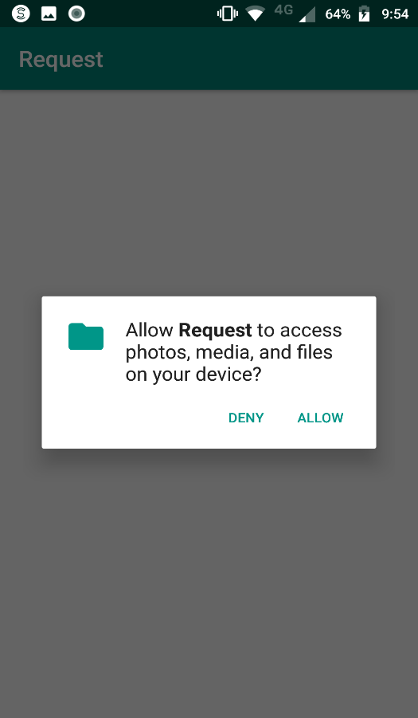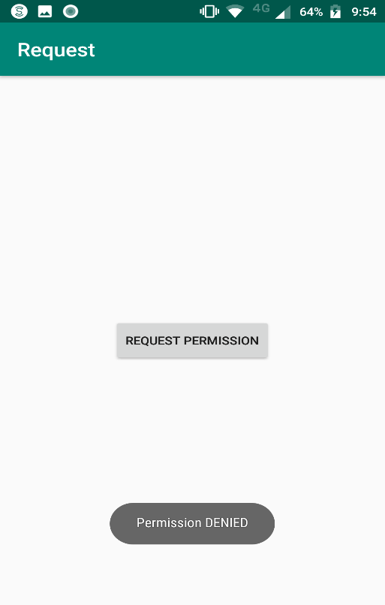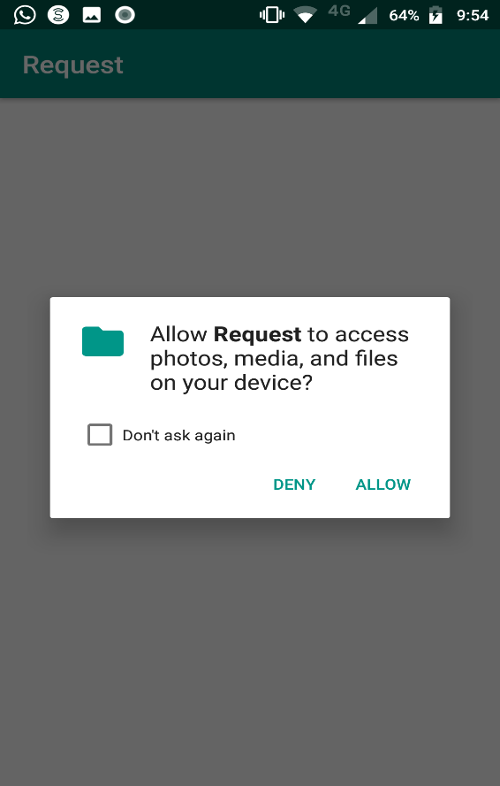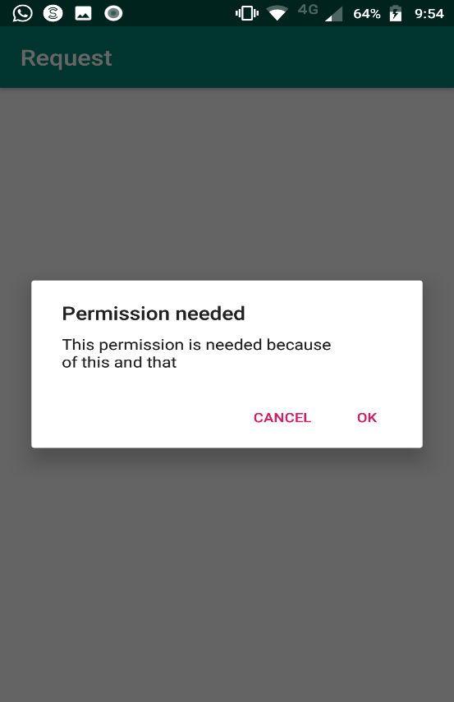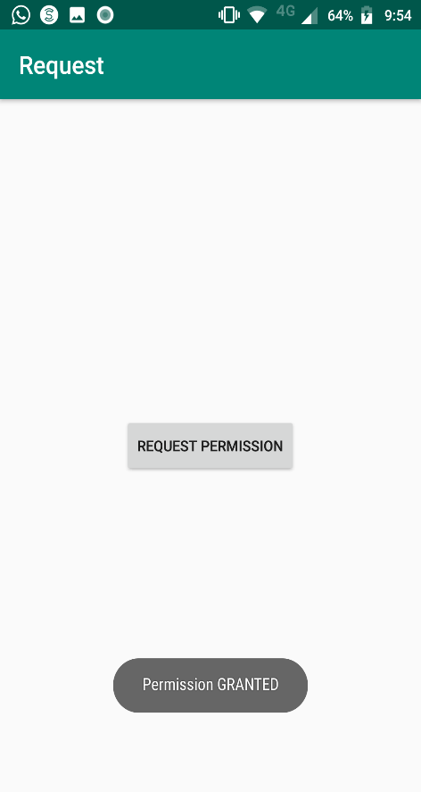
practical 9
Aim: Programs on Activity Life cycle of android
<?xml version="1.0" encoding="utf-8"?>
<android.support.constraint.ConstraintLayout xmlns:android="http://schemas.android.com/apk/res/android"
xmlns:app="http://schemas.android.com/apk/res-auto"
xmlns:tools="http://schemas.android.com/tools"
android:layout_width="match_parent"
android:layout_height="match_parent"
tools:context="example.javatpoint.com.activitylifecycle.MainActivity">
<TextView
android:layout_width="wrap_content"
android:layout_height="wrap_content"
android:text="Hello World!"
app:layout_constraintBottom_toBottomOf="parent"
app:layout_constraintLeft_toLeftOf="parent"
app:layout_constraintRight_toRightOf="parent"
app:layout_constraintTop_toTopOf="parent" />
</android.support.constraint.ConstraintLayout>

MainActivity.java
package example .com.activitylifecycle;

import android.app.Activity;
import android.os.Bundle;
import android.util.Log;

public class MainActivity extends Activity {

@Override
protected void onCreate(Bundle savedInstanceState) {
super.onCreate(savedInstanceState);
setContentView(R.layout.activity_main);
Log.d("lifecycle","onCreate invoked");
}
@Override
protected void onStart() {
super.onStart();
Log.d("lifecycle","onStart invoked");
}
@Override
protected void onResume() {
super.onResume();
Log.d("lifecycle","onResume invoked");
}
@Override
protected void onPause() {
super.onPause();
Log.d("lifecycle","onPause invoked");
}
@Override
protected void onStop() {
super.onStop();
Log.d("lifecycle","onStop invoked");
}
@Override
protected void onRestart() {
super.onRestart();
Log.d("lifecycle","onRestart invoked");
}
@Override
protected void onDestroy() {
super.onDestroy();
Log.d("lifecycle","onDestroy invoked");
}
}
Output:
